**Sugar Rush Cake Shop**

Web programming class project 2023/2024

|  |  |  |  |  |
| --- | --- | --- | --- | --- |
| Student Name in English | Student Name in Arabic | Student ID | Section time as shown in zajel | Work percentage |
| Sadeen Hawash | سدين هواش | 12029024 | Sun-Tue-Thu 9-10 | 50% |
| Jumana Saif | جمانة سيف | 12113114 |  |  |
|  |  |  |  |  |

Date/time

---------------------------------------------This section is intended for the Instructor---------------------------------------

|  |  |
| --- | --- |
| **Topic** | **Mark** |
| Project Idea |  |
| Project Complexity |  |
| Project Tools |  |
| Project Requirements and Modeling |  |
| Project Discussion |  |
| Project Completeness |  |
| Project Output Results or reporting |  |
| Project Administration and Management |  |
| Project Report |  |
| Team work |  |
|  |  |
|  |  |
|  |  |
|  |  |
|  |  |

**Table Of Contents**

Table of Contents

Abstract 3

Introduction 4

Project Requirnments 5

**Tools Used In The project** 8

**Project Database** 9

**GUI** 10

**Page Loader** 10

**Home Page** 10

**About us** 17

**Contact us** 19

**Shop** 19

**Drinks page** 19

**Desert** 25

**Single product veiw** 32

**Sign in** 33

**Sign up** 33

**User profile** 35

**Admin** 39

**Responsive** 44

**Tables** 72

**Conclusion** 83

**Refrences** 84

# Abstract

This report outlines the development and implementation of our online platform dedicated to premium ice cream, delectable desserts, and refreshing drinks. The website combines aesthetic design with user-friendly navigation, offering customers an engaging and convenient shopping experience.

# Introduction

Welcome to our virtual haven, where the world of delectable delights collides with the ease of online accessibility. Our website is not just a platform; it's a tailored experience dedicated to meeting every craving for ice cream, desserts, and refreshing drinks. We've curated a space that not only caters to the individual seeking a sweet treat but also extends to those looking to create their own dessert haven.

At the heart of our site is a comprehensive selection that goes beyond the ordinary. From premium ice creams and mouth-watering desserts to a medley of refreshing drinks, we've assembled a symphony of flavors to captivate your taste buds.

What sets us apart is our attention to the finer details of celebration. Beyond the realm of daily cravings, our platform acknowledges the beauty of gifting in nature's language. Be it weddings, birthdays, or special occasions

To ensure a personalized and secure experience, our users are invited to log in via email and password, unlocking a world of exclusive offerings and a seamless shopping journey. Prices, offers, and a visual feast of our offerings are laid bare for you, simplifying the experience of turning your cravings into reality.

Join us in this digital confectionery, where every login opens the door to a world of sweetness, and every order is a step toward creating your own delightful moments.

# **Project Requirnments**

**Admin_info**

Attributes: id(unique), name, email, phone, address, oppeningTime1, oppeningTime2, password.

**The system has only one administrator who’s responsible for everything.**

**Users**

Attributes: userId(unique), name, email, password, phone, address, password.

**Each user can make orders(add to cart, checkout, payment,..), send messages to the admin, only if has an account.**

**Products**

Attributes: productId(unique), name, category, type, price, image, bgImage.

**The Products are displayed to the customer in the shop section, each product can be added to the customer cart, wish list, and also it can be added to the best seller, edited or deleted by the admin.**

**Best Seller**

Attributes: bestSellerId(unique), productId, name, category, type, price, image, bgImage.

**The best seller products are added by the admin, and displayed to the customers as best sellers.**

**New Products**

Attributes: newProductId(unique), productId, name, category, type, price, image, bgImage.

**The products are added by the admin, and displayed to the customers as new products.**

**Cart**

Attributes: id(unique), userId,productId, name, price, quantity, image.

**The cart display the products that have been added by the customer, the customer can update the product quantity, and also remove the product from the cart.**

**Wish List**

Attributes: id(unique), userId,productId, name, price, image.

**The wish list display the products that have been added by the customer, the customer can add the products to the cart, and also remove the product from the wish list.**

**Orders**

Attributes: OrderId(unique), orderCost, userId, name, email, address, phone, city, notes, date, status.

**Contains the customer shipping information, the cost which is calculated from the products prices in the cart.**

**Order Items**

Attributes: OrderId(unique), userId, productId, name, price, quantity, image, date.

**Contains the customer order items.**

**Messages**

Attributes: id(unique), userId, name, email, number(phone-number), message.

**Contains the messages sent by customers.**

**Candy Tables Messages**

Attributes: id(unique), userId, name, email, number(phone-number), message.

**Contains the messages sent by customers who want to place an order to organize a dessert table or cake for their events.**

# **Tools Used In The project**

* + **Applications**

PHPStorm

VScode

Xampp

* + **Languages, libraries and frameworks**

HTML

CSS

Java Script

PHP

MySQl

JQuery

Bootstrap

# **Project Database**

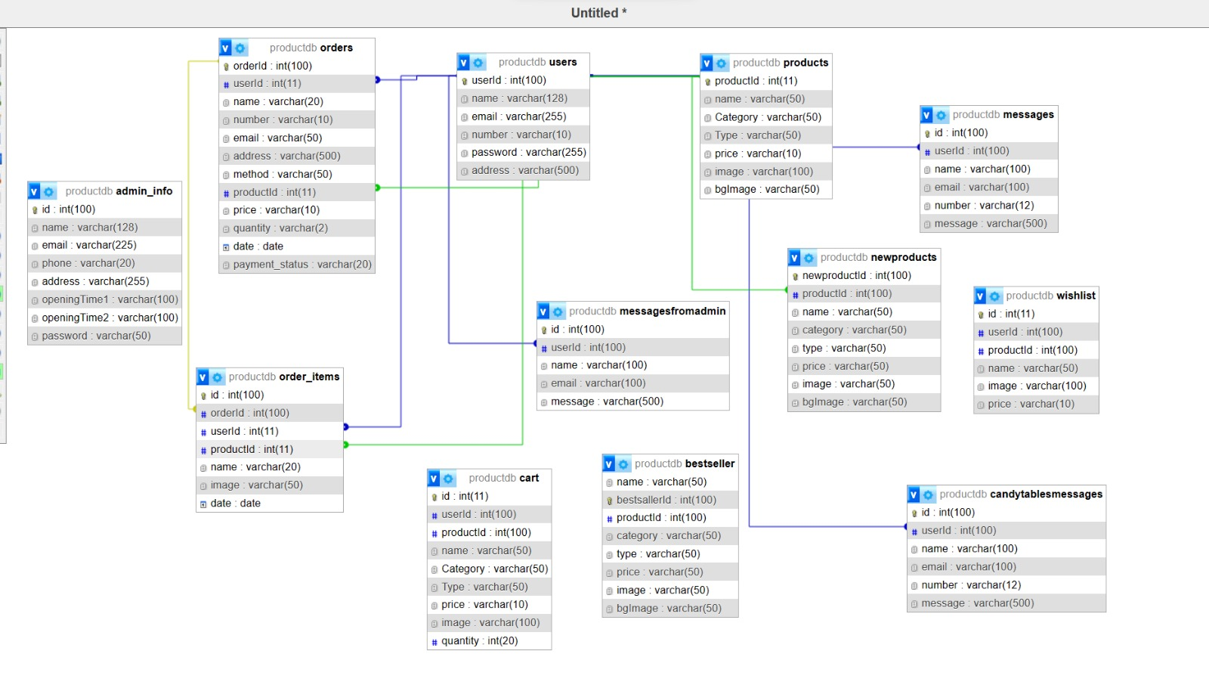

# **GUI**

# **Page Loader**

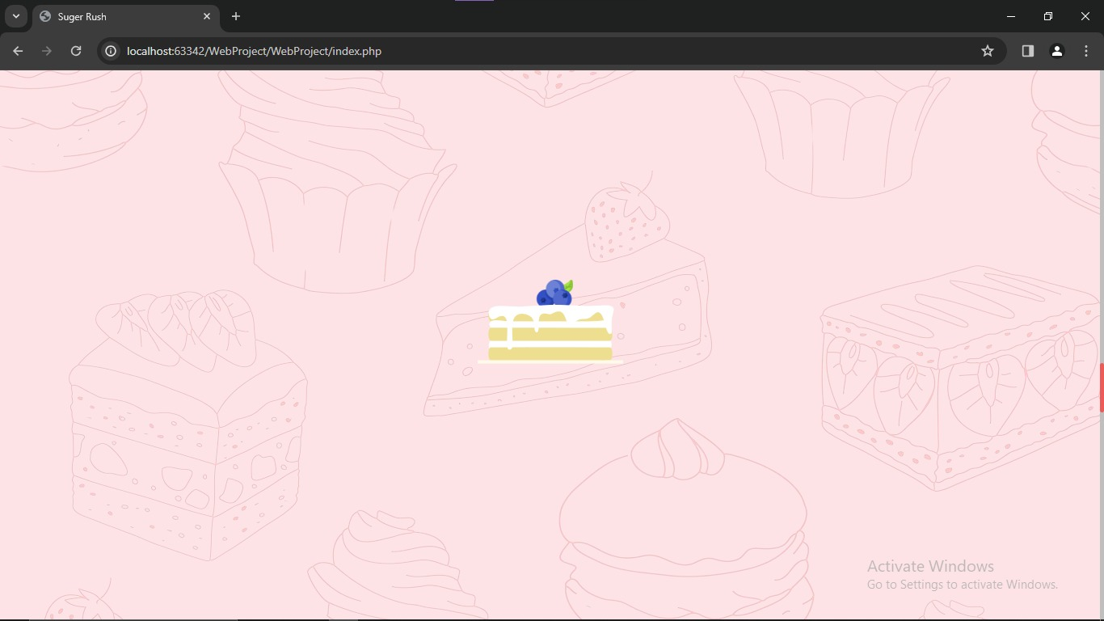

# **Home Page**

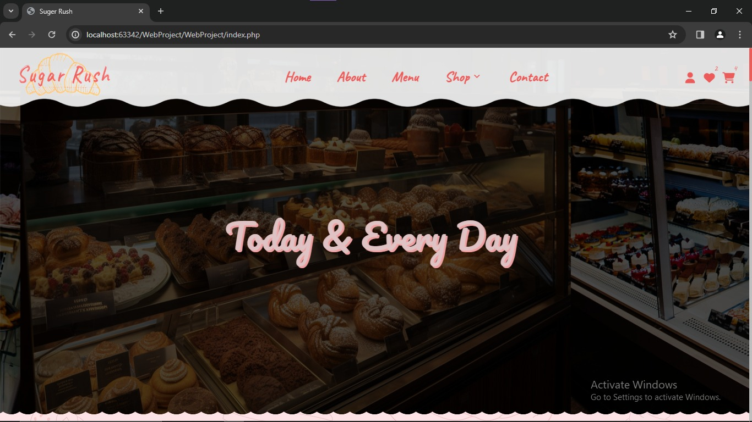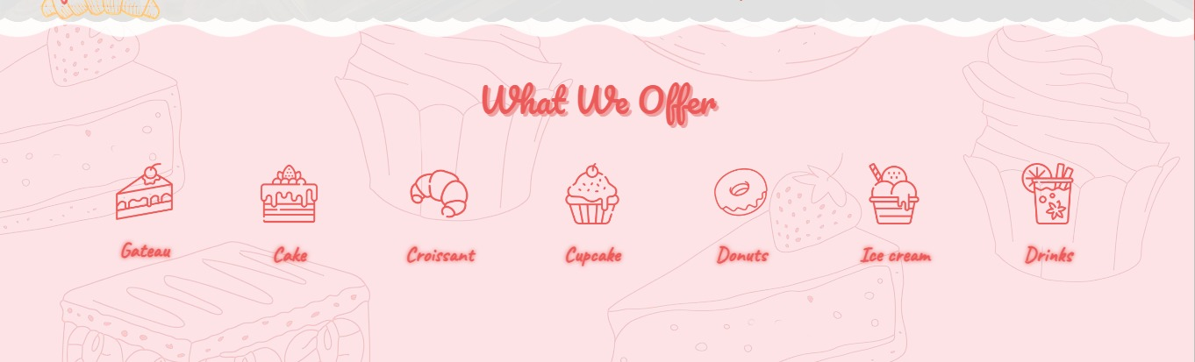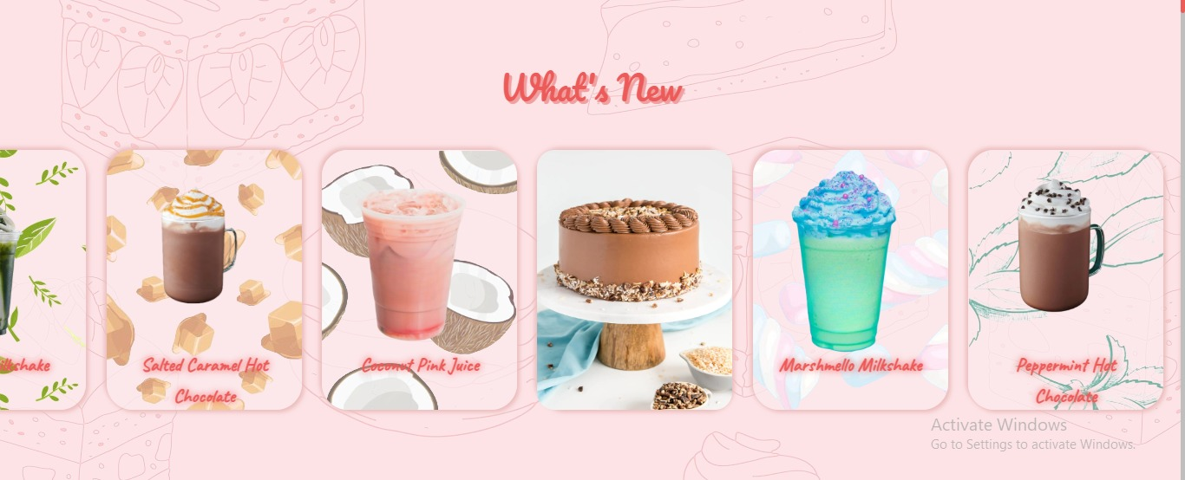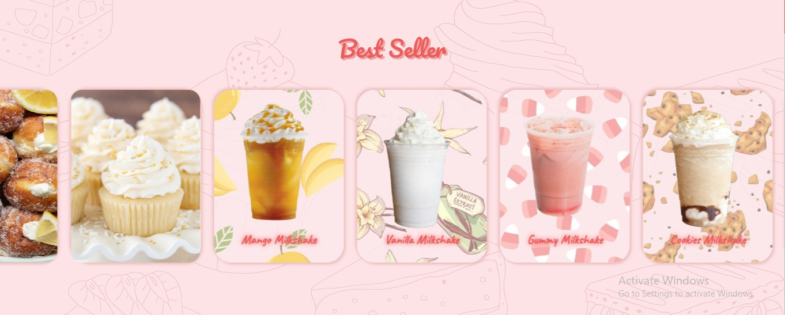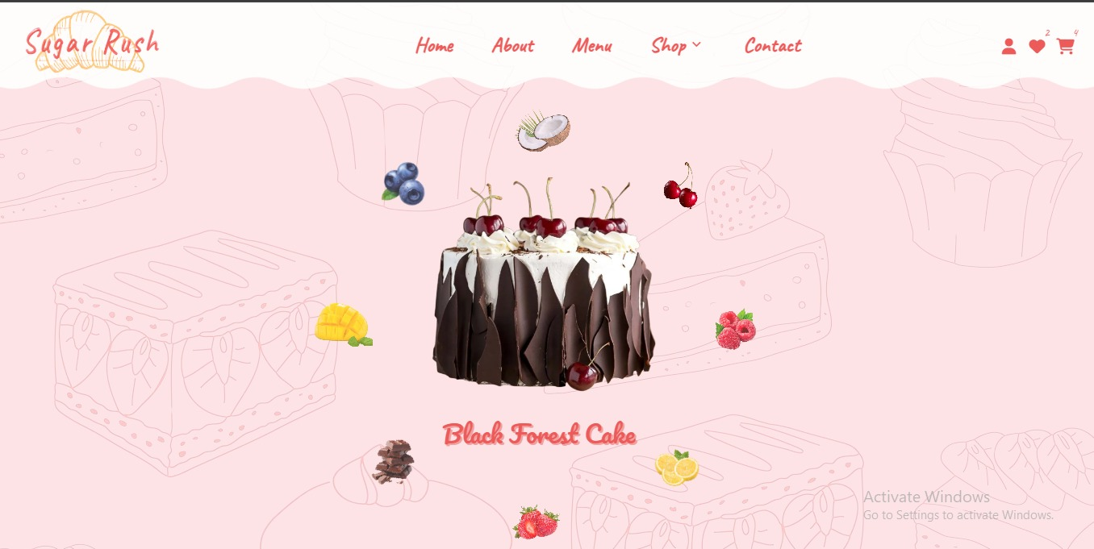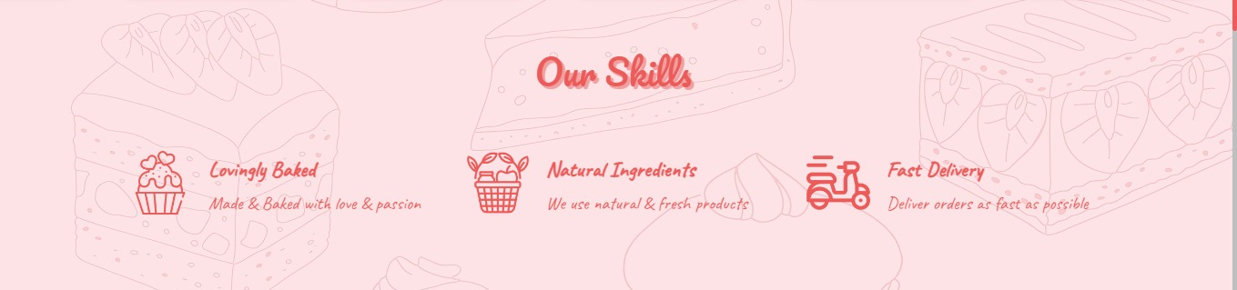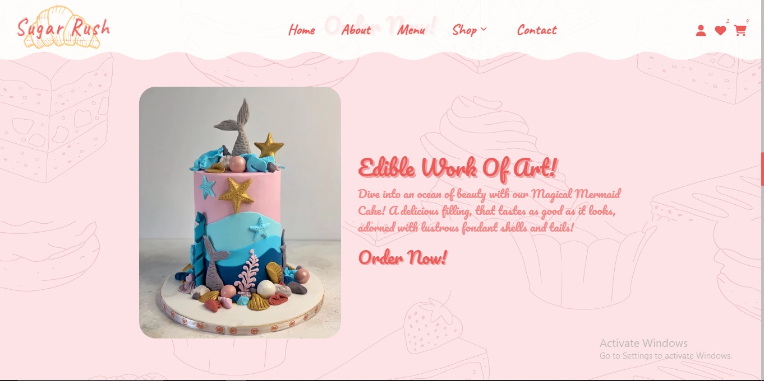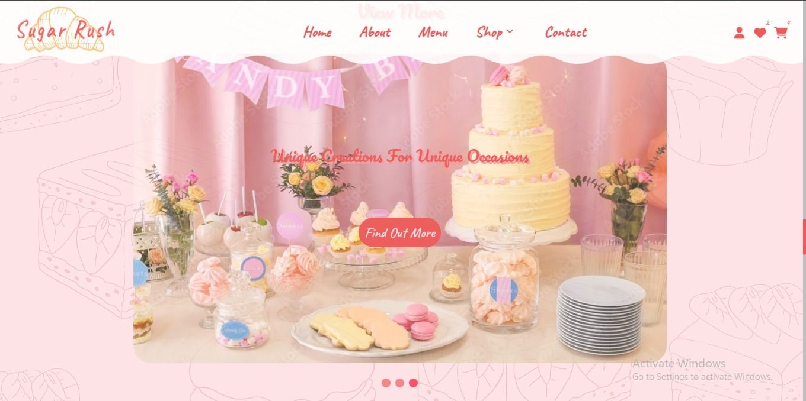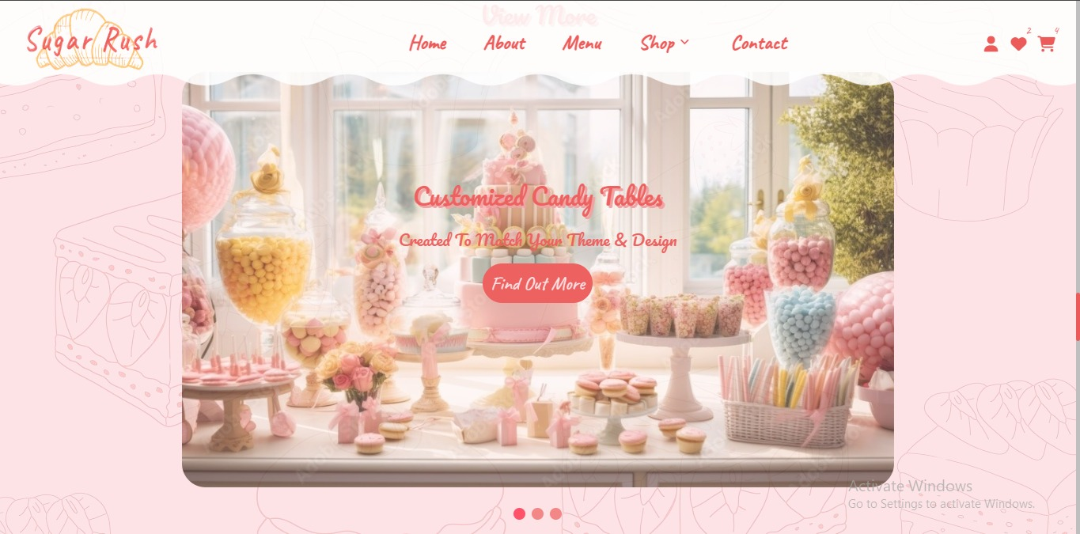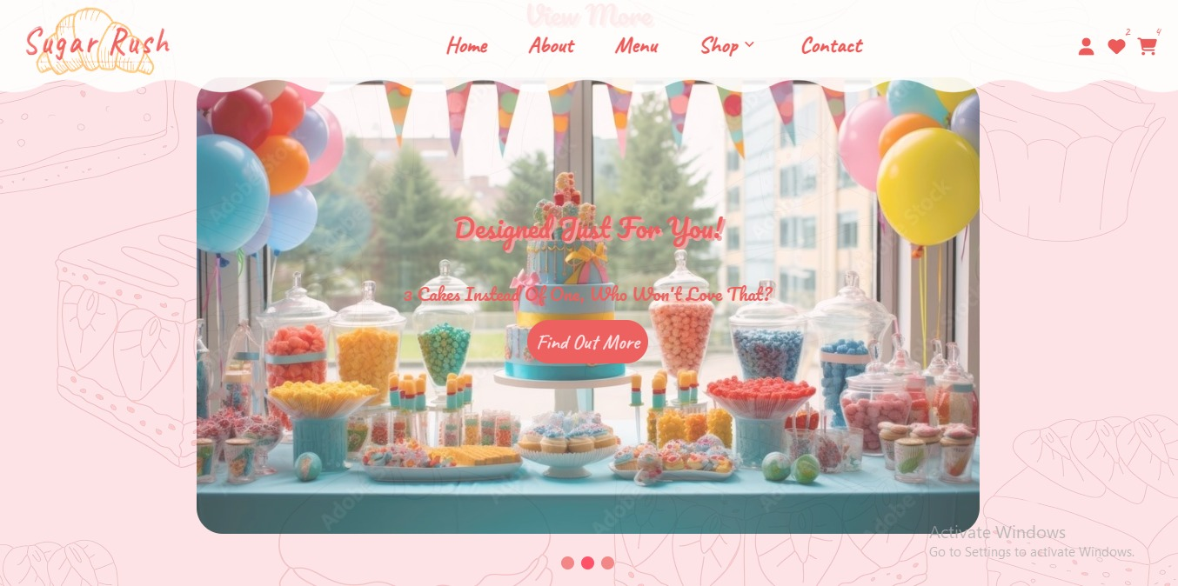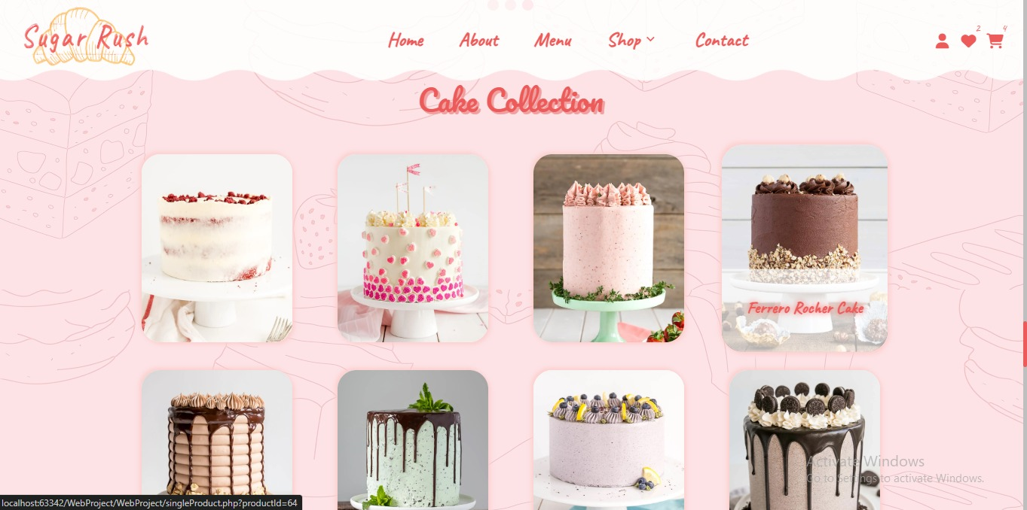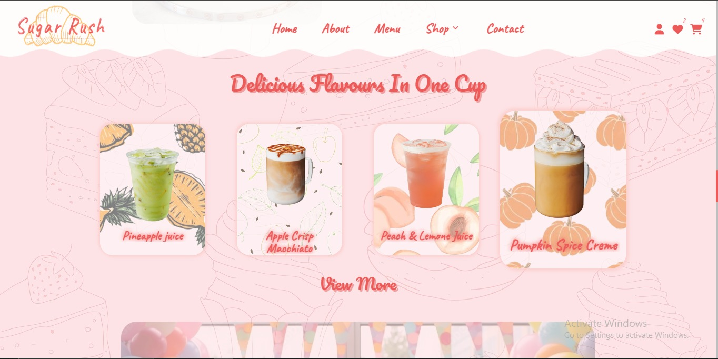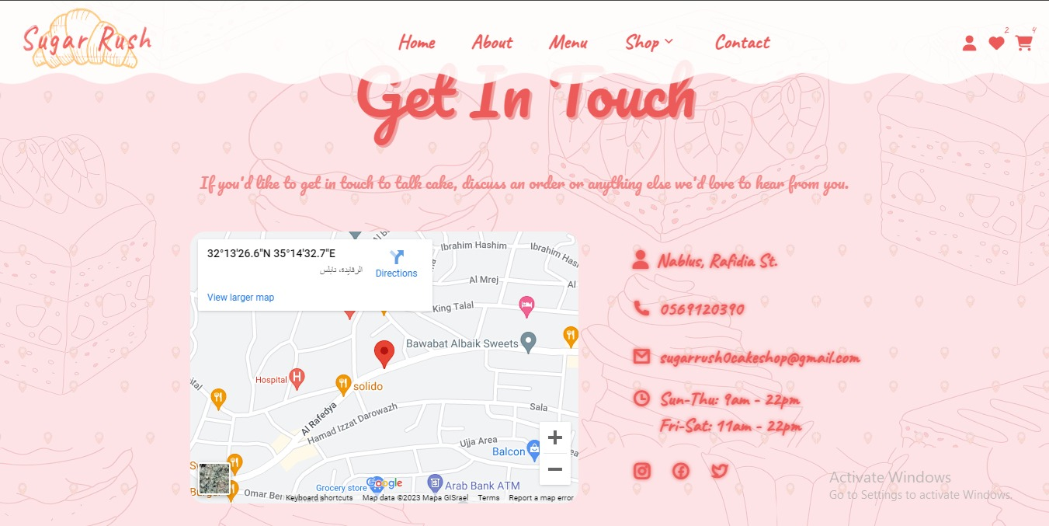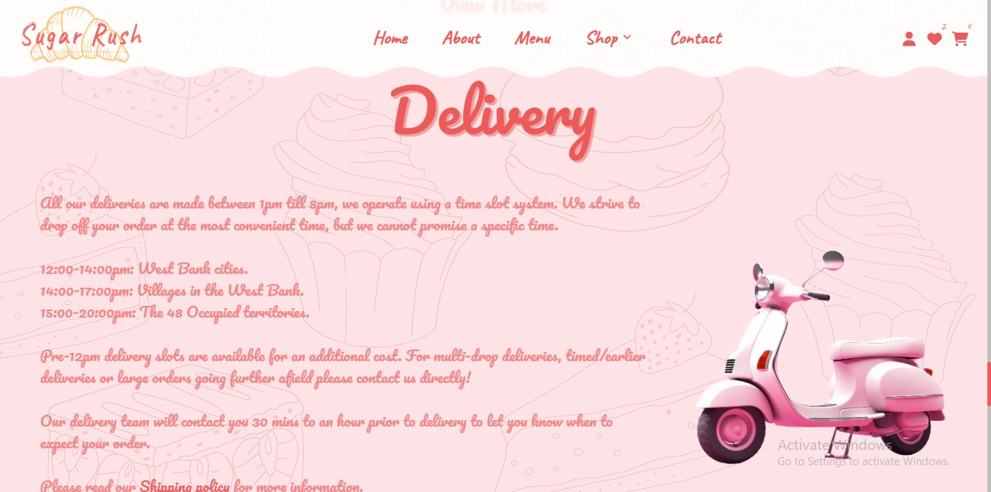

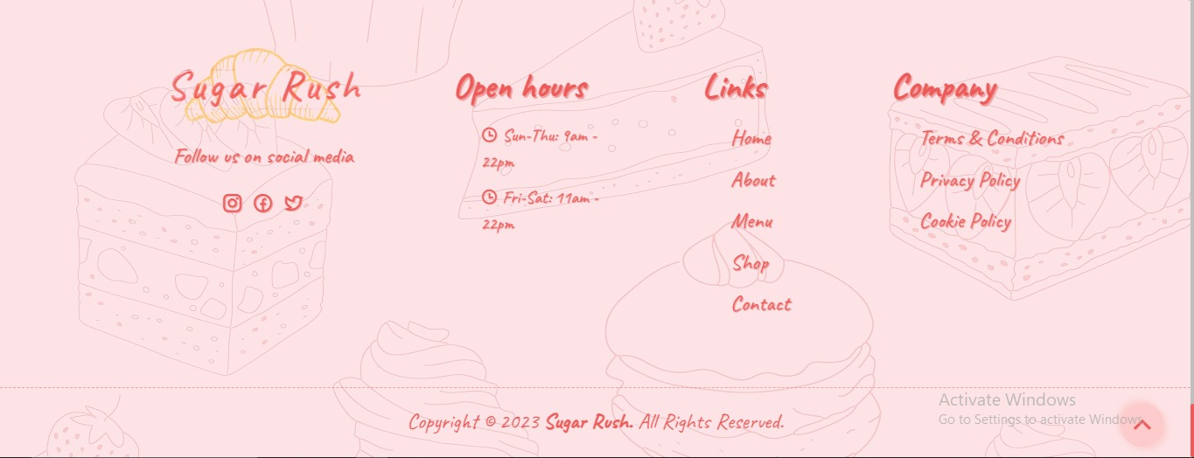

# **About us**

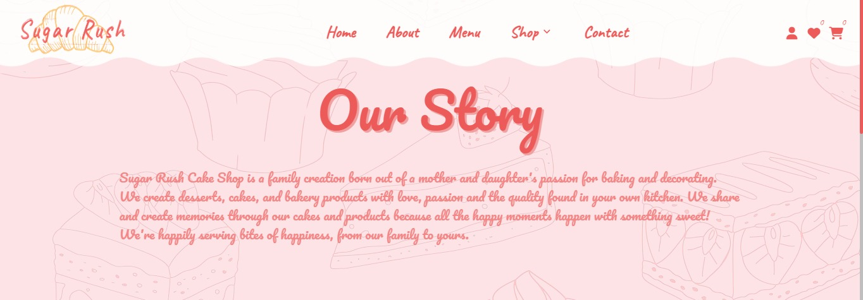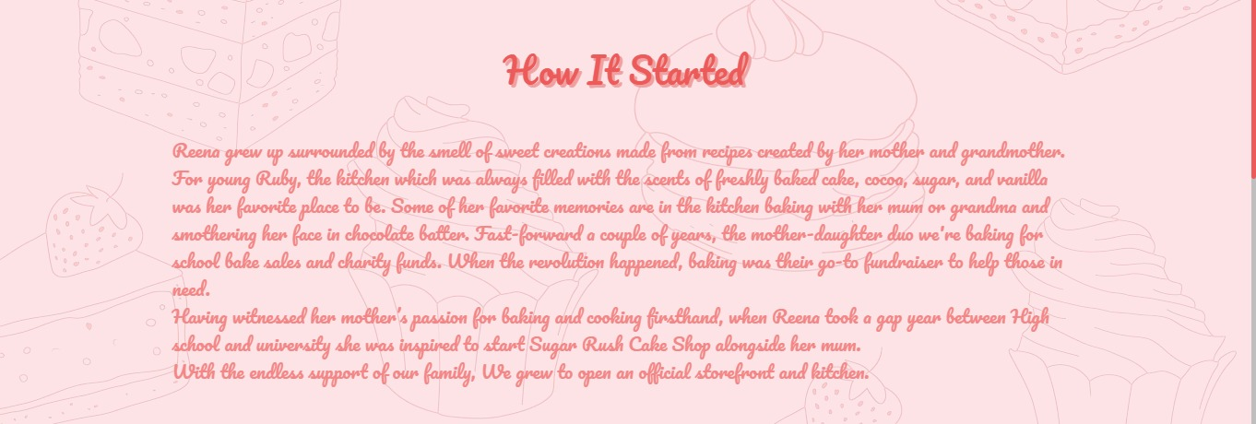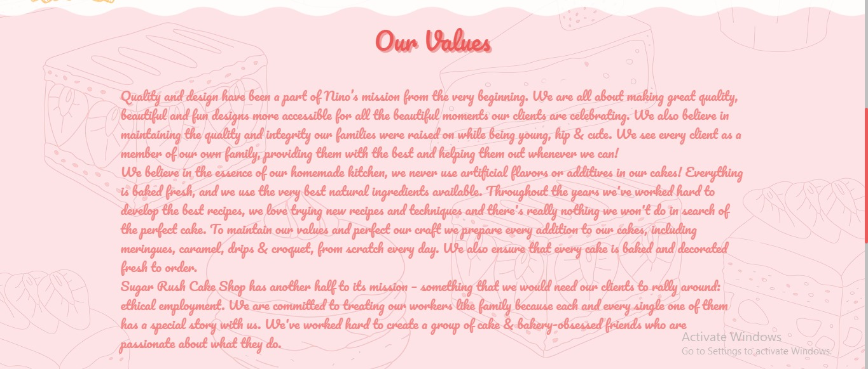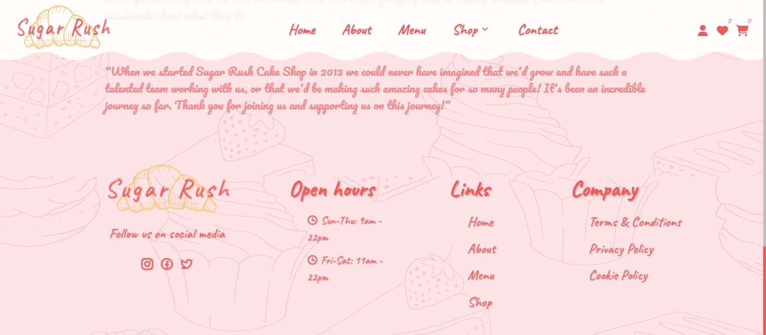

# **Contact us**

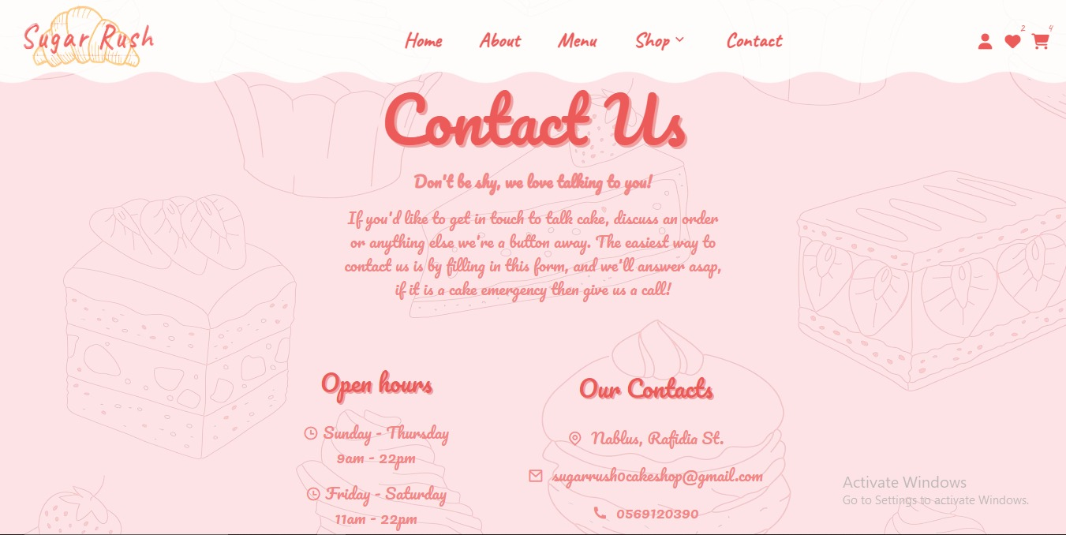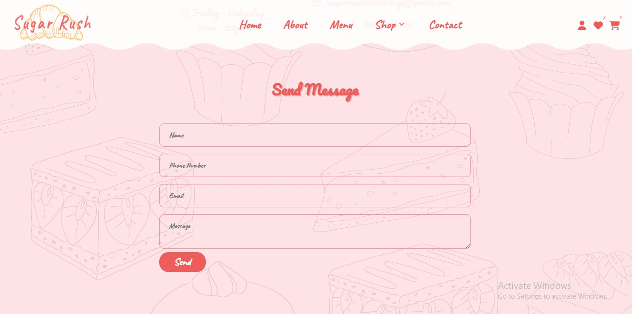

# **Shop**

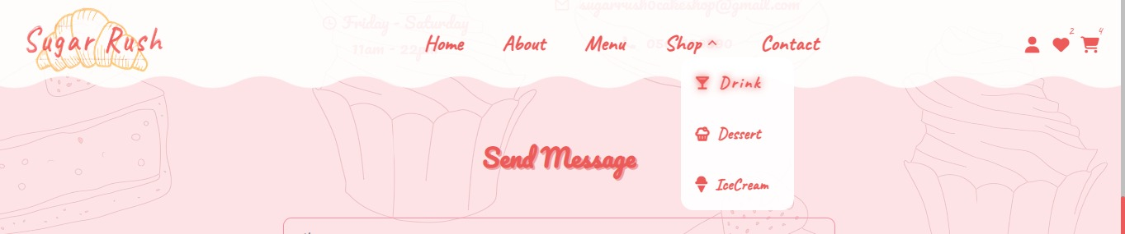

# **Drinks page**

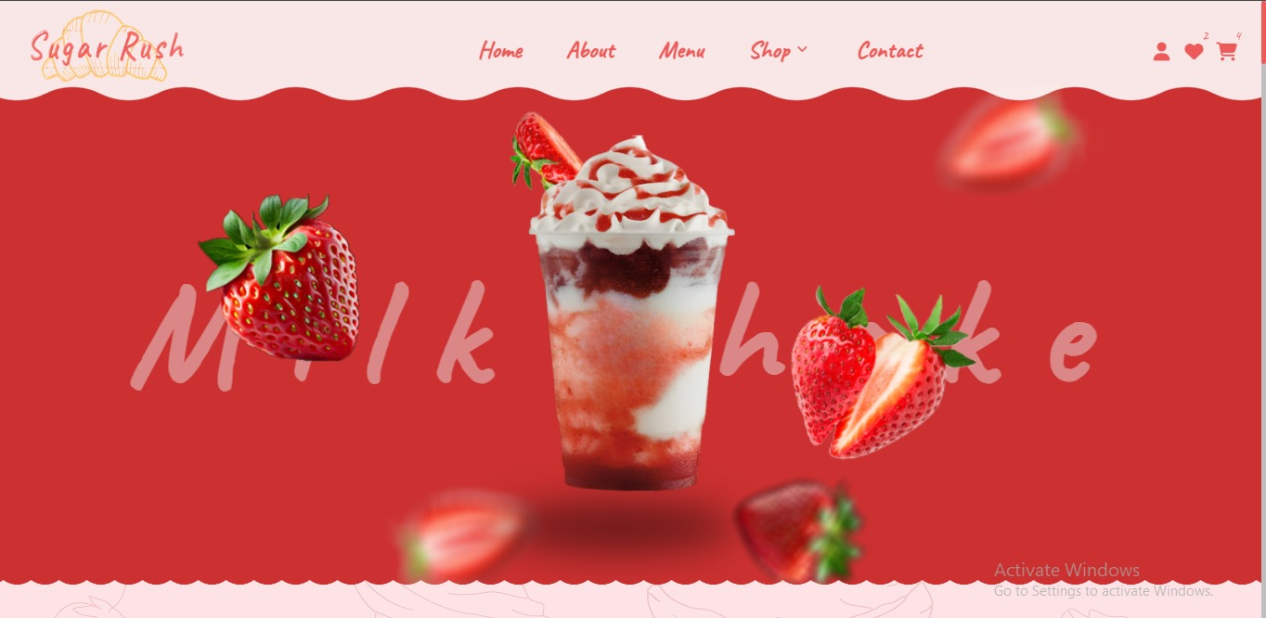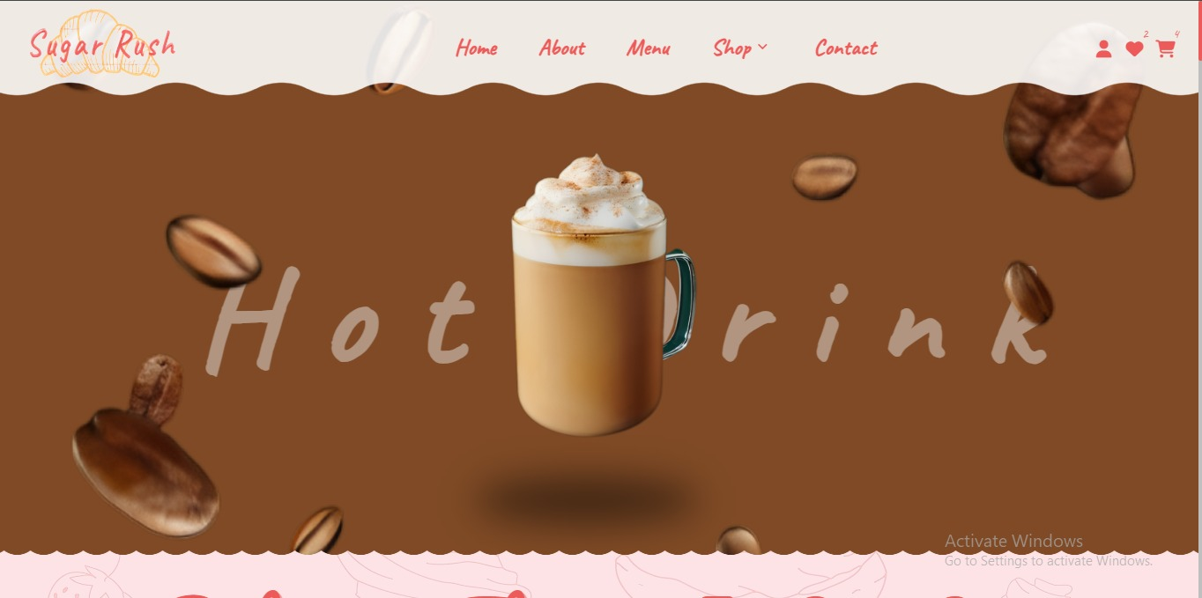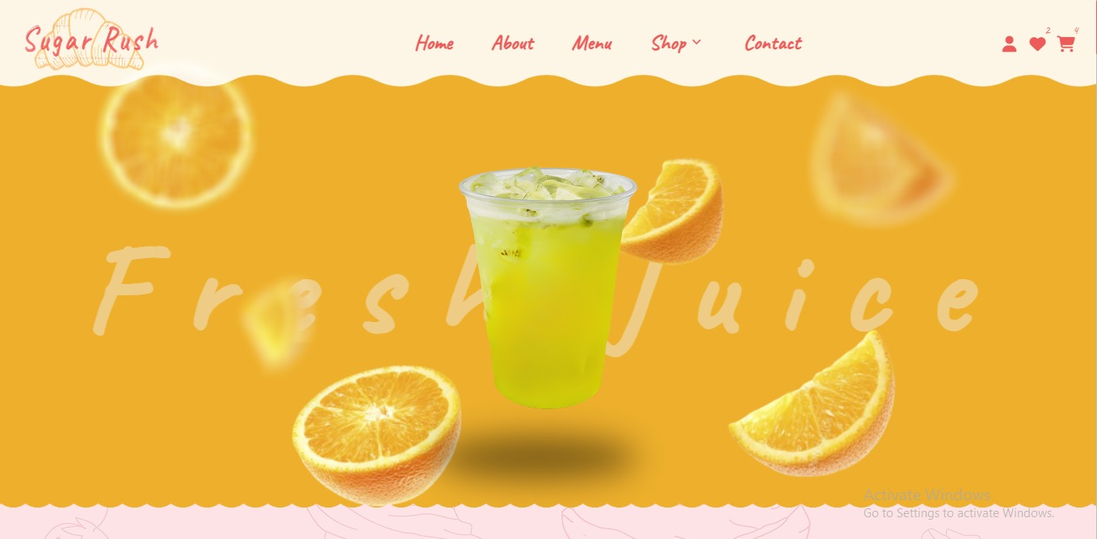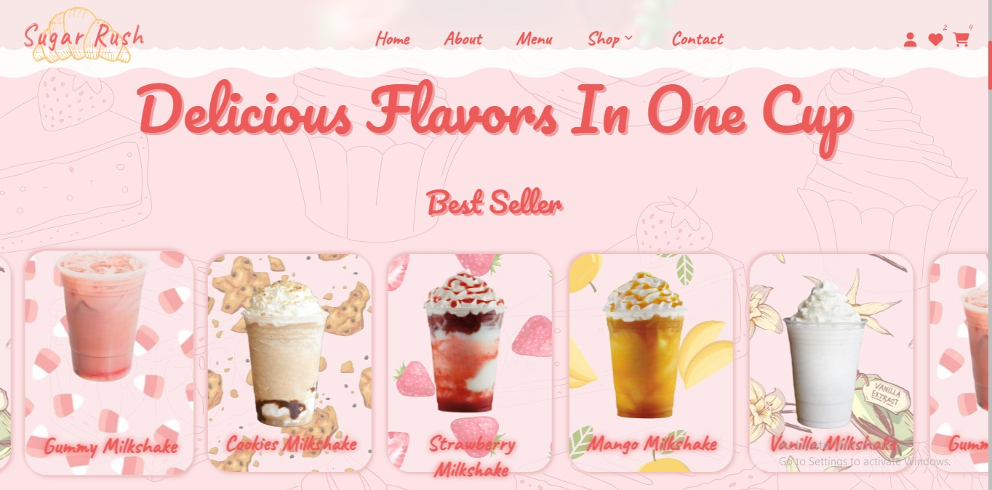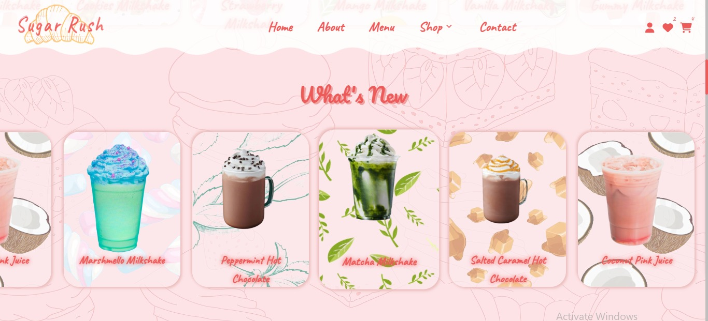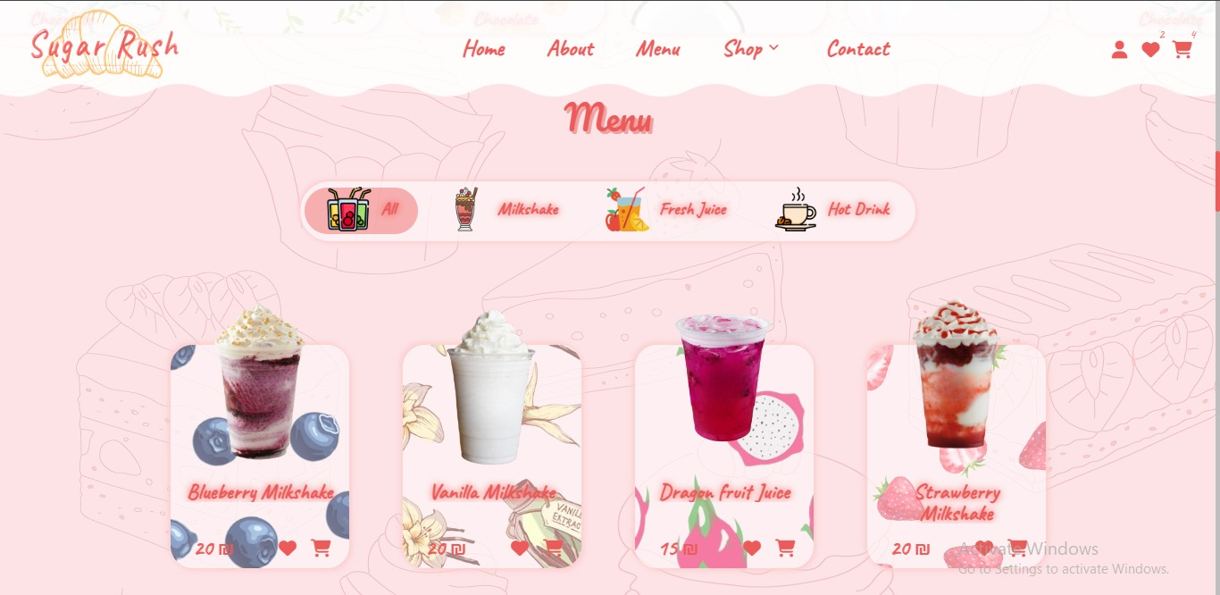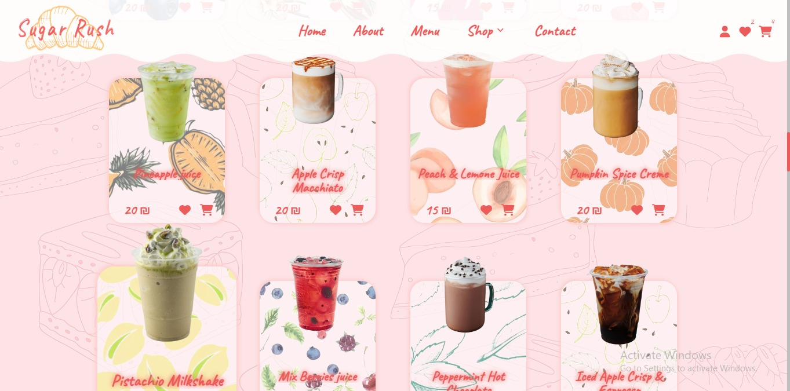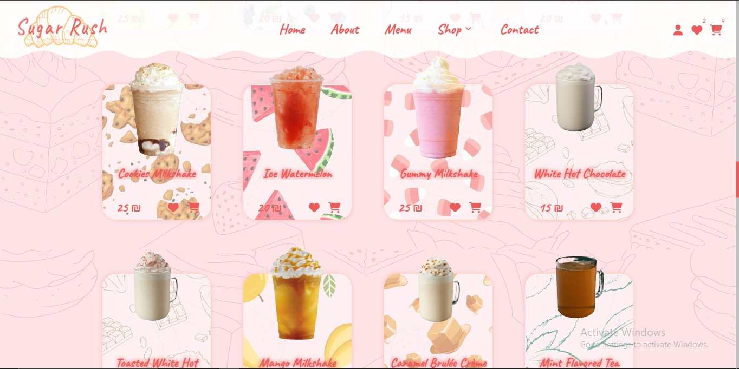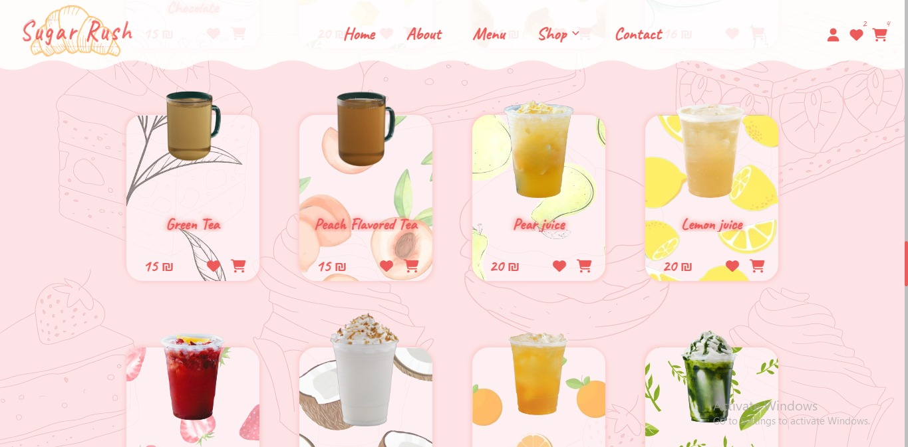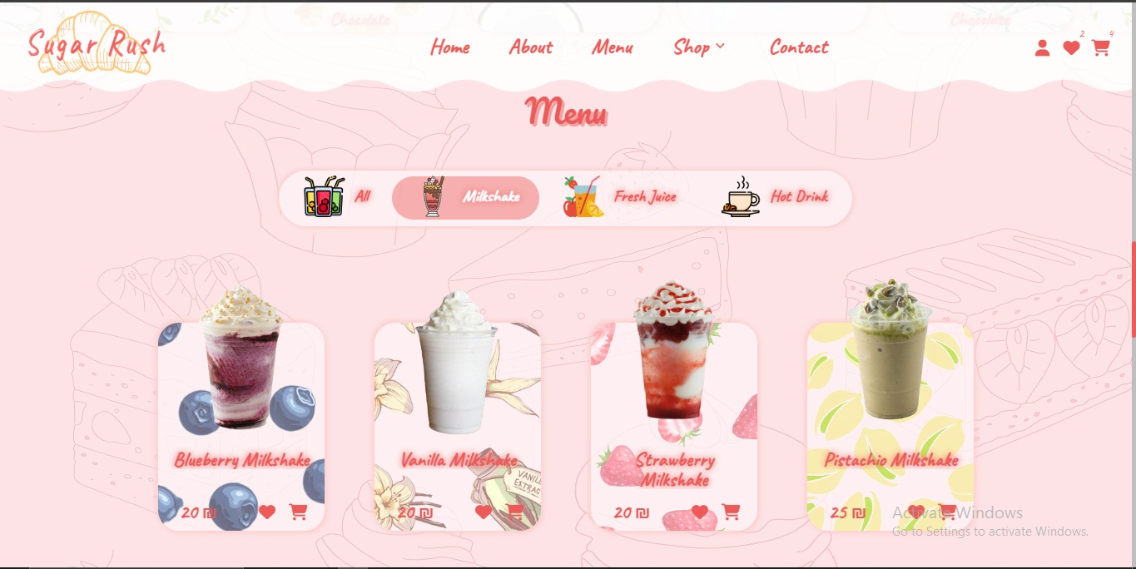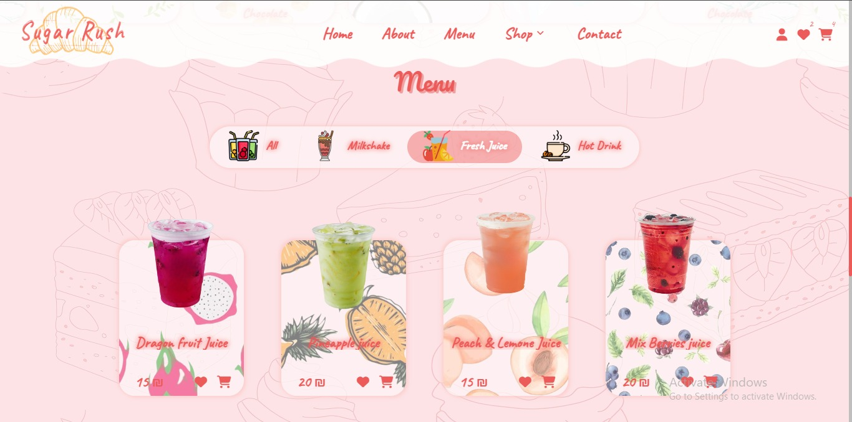

# **Desert**

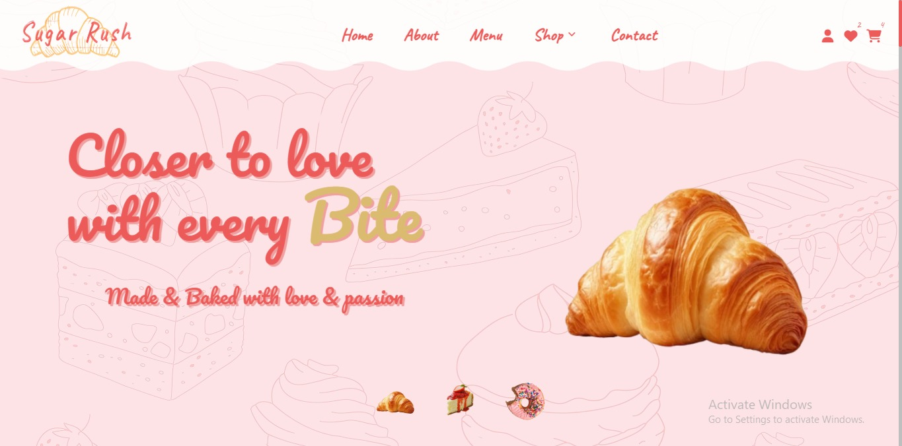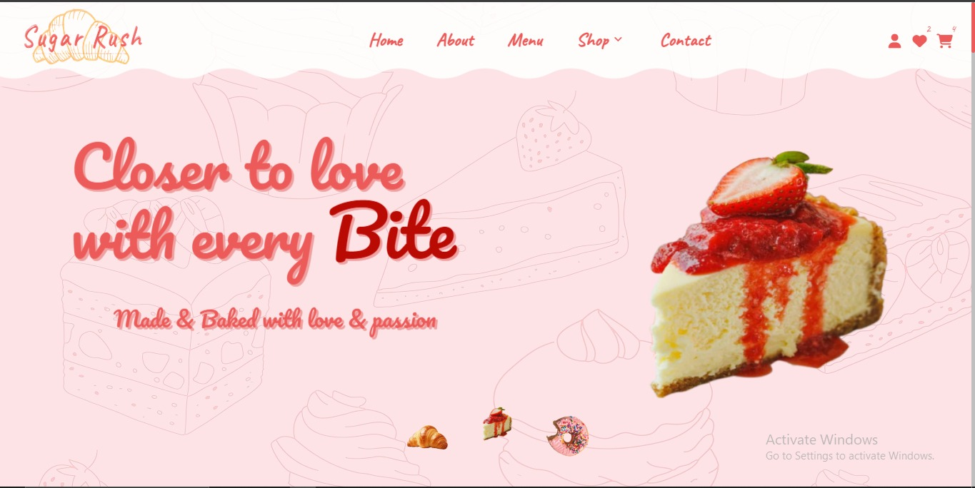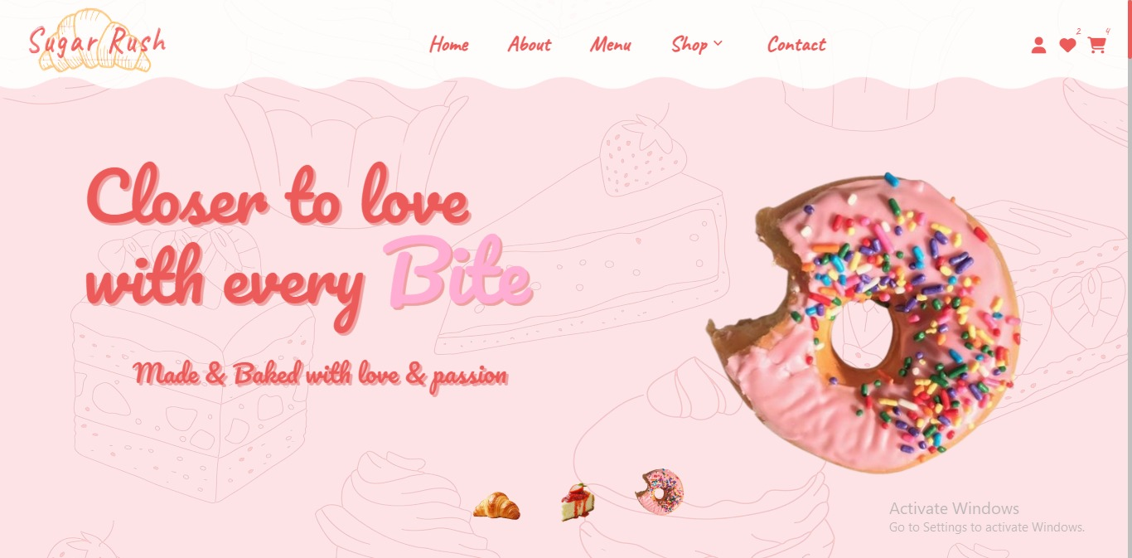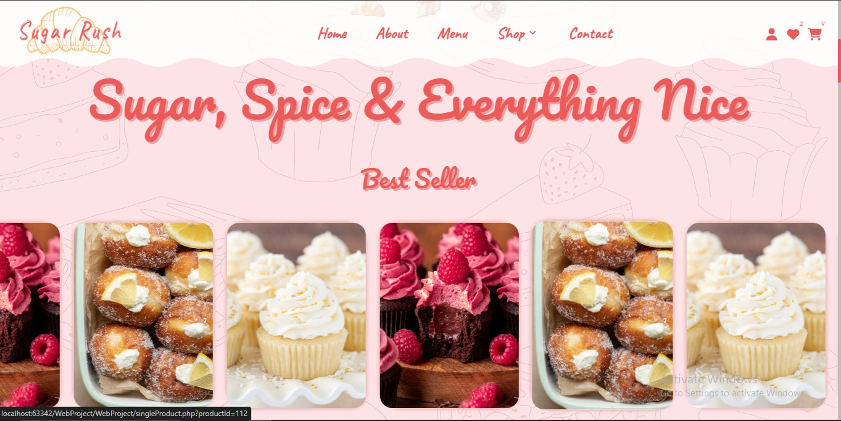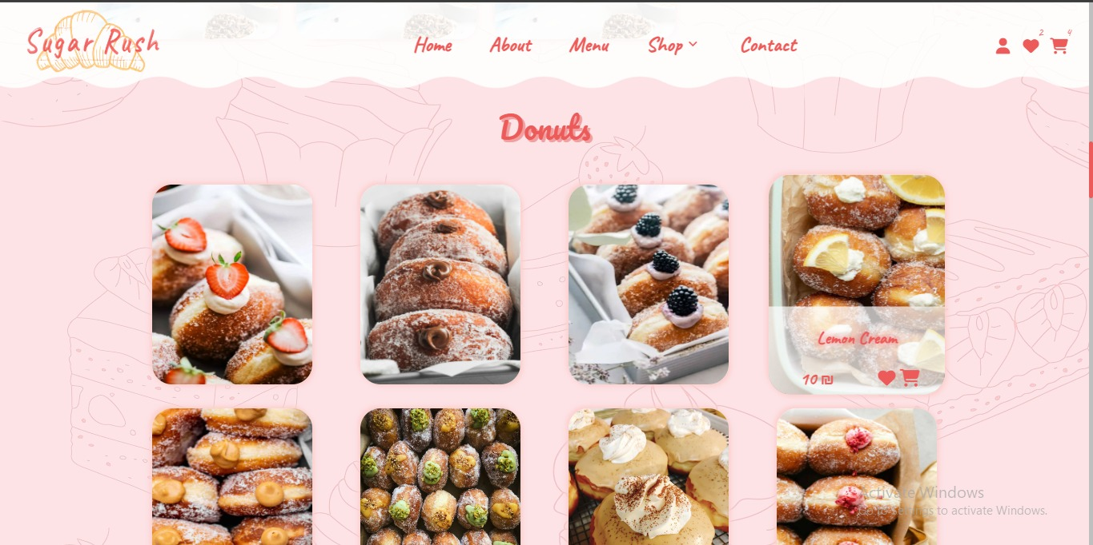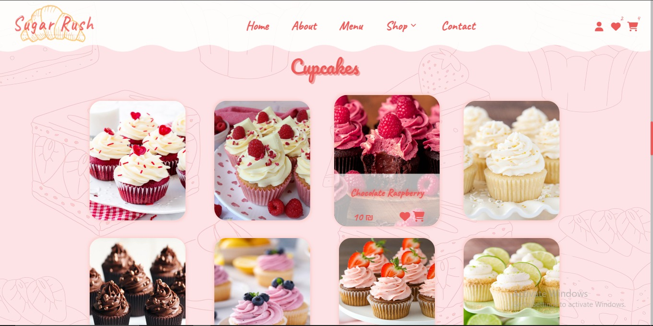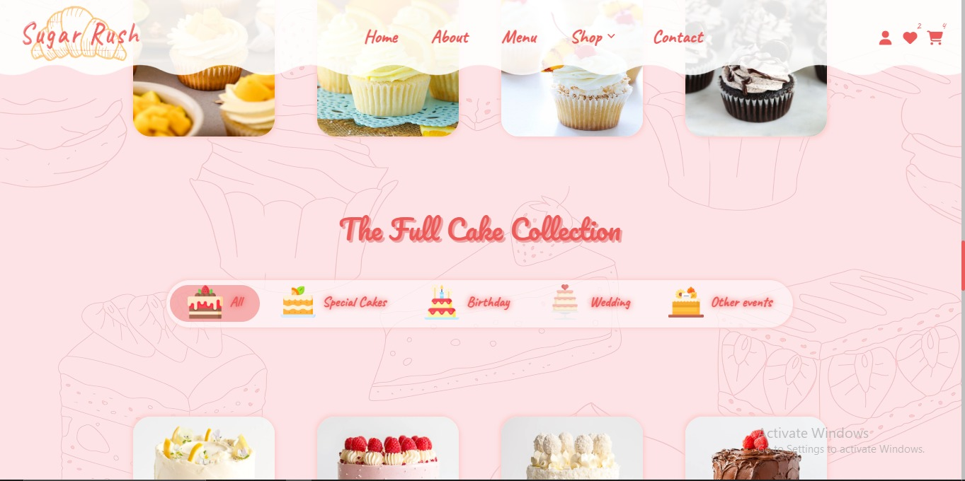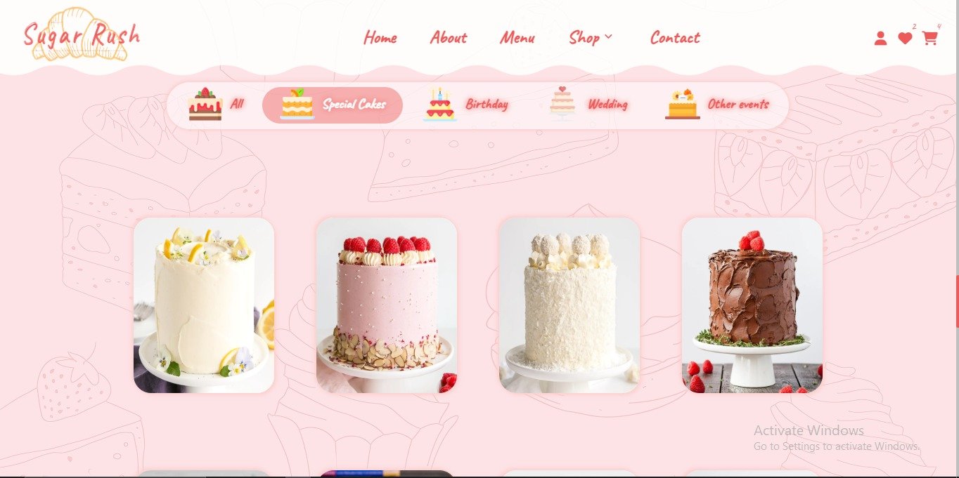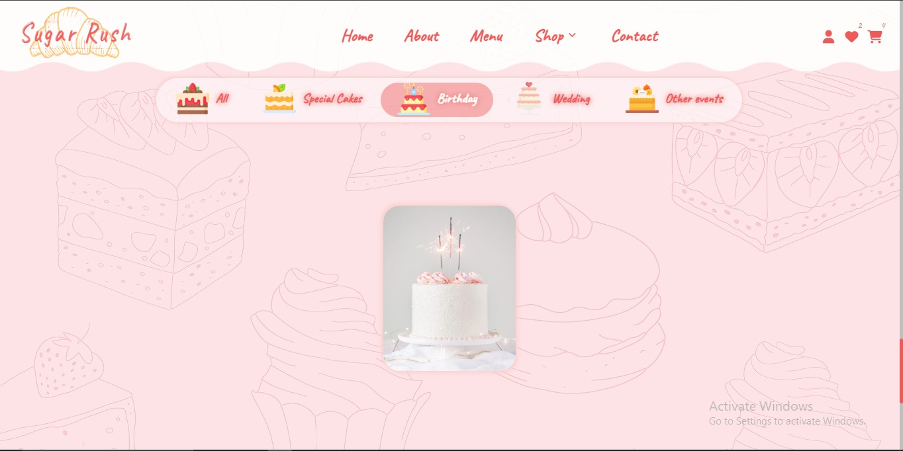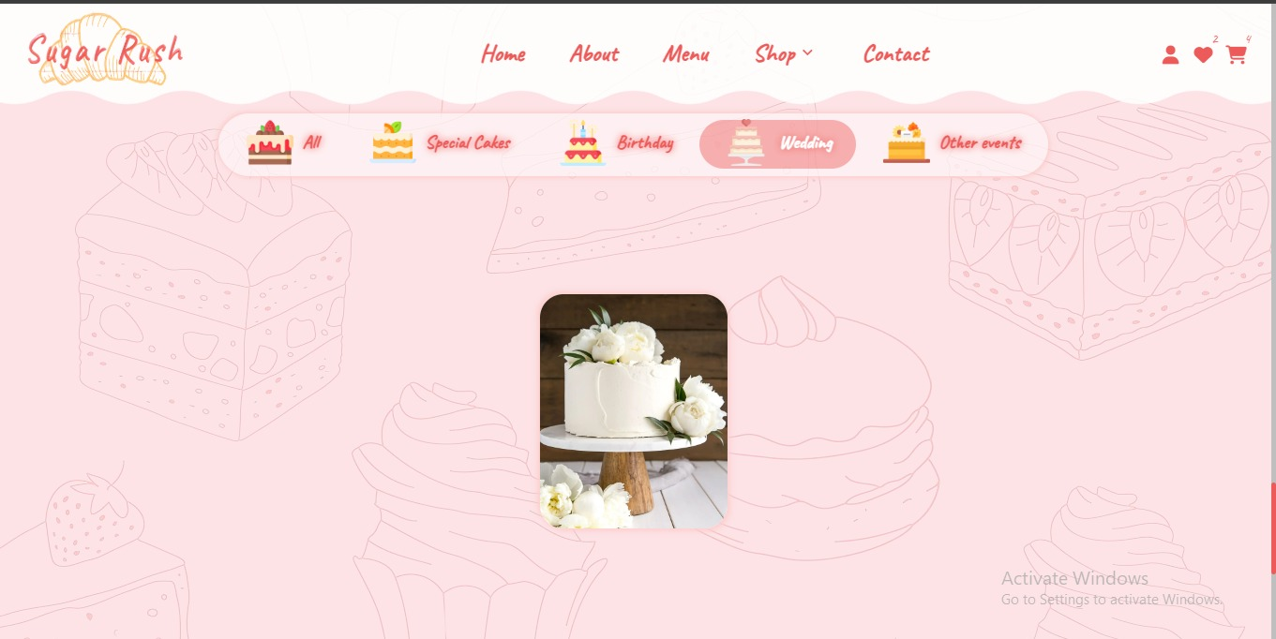

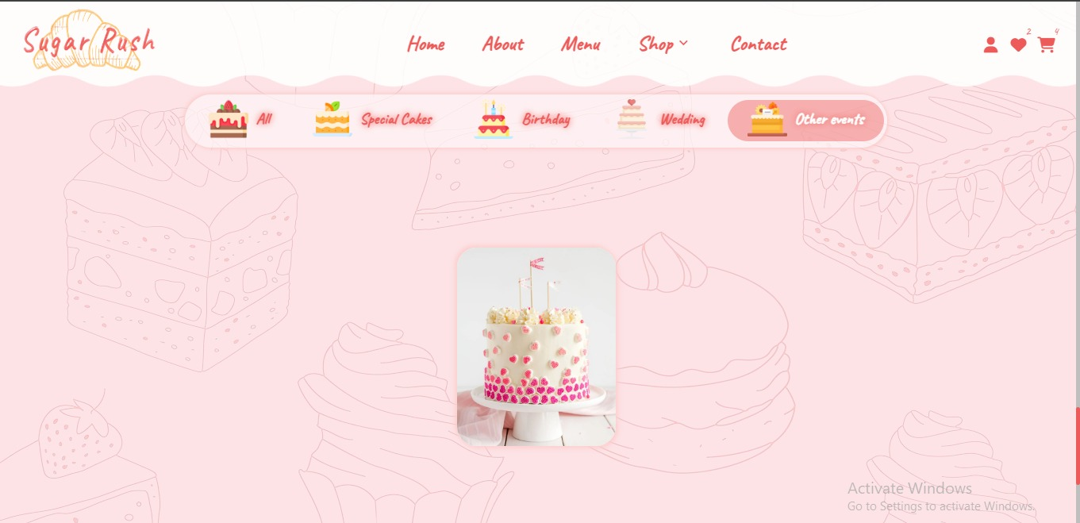

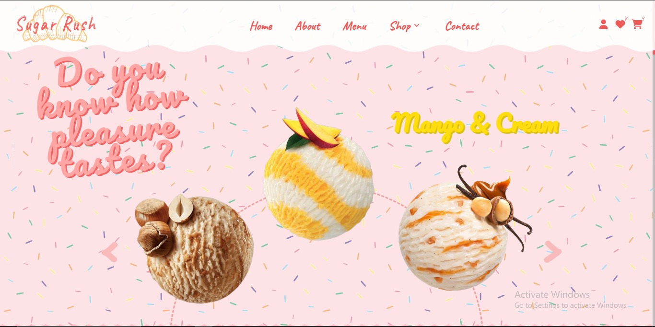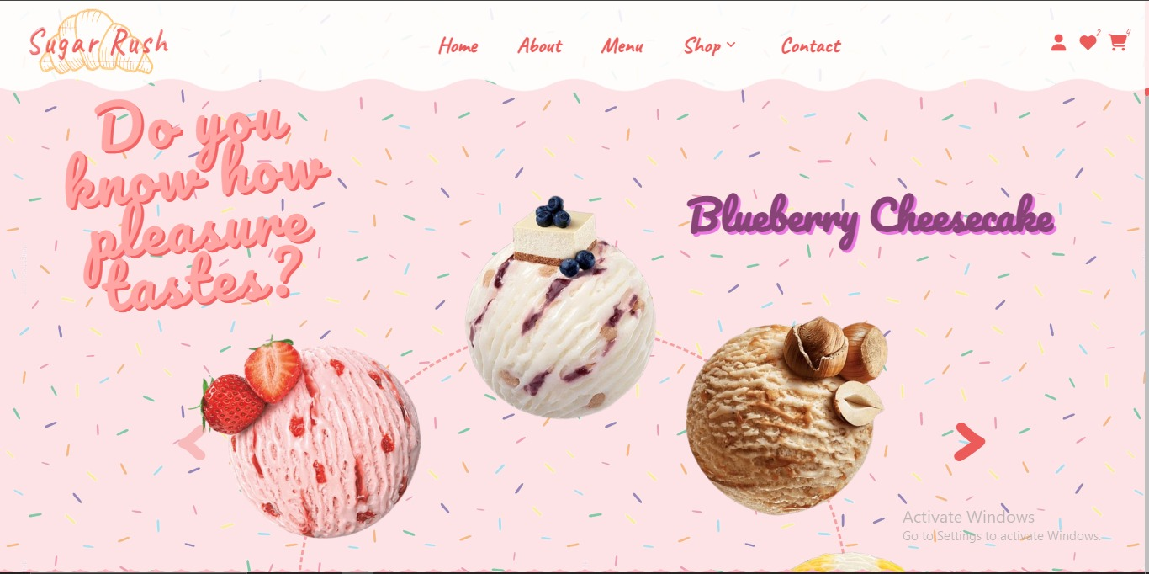

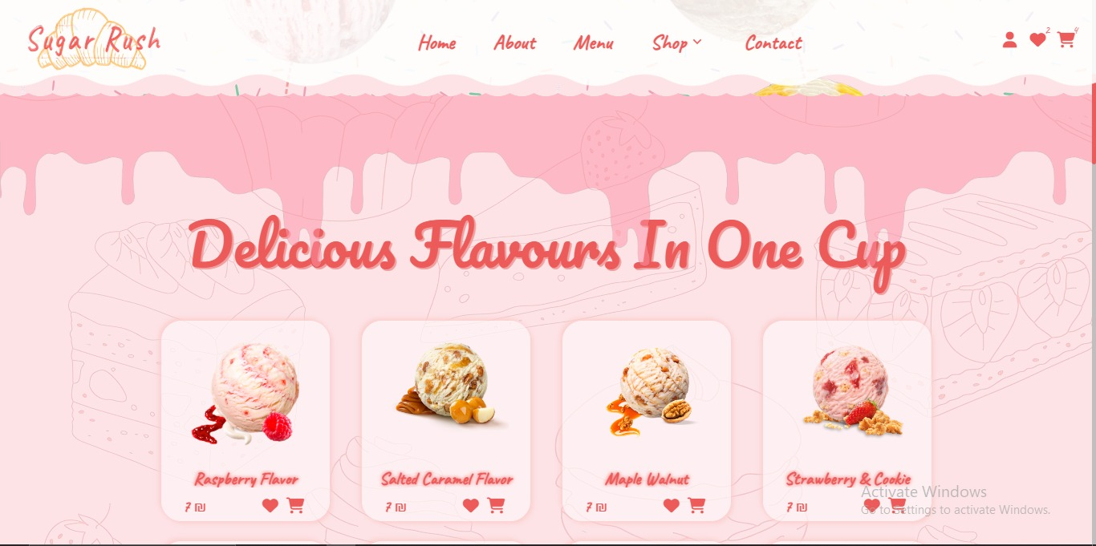

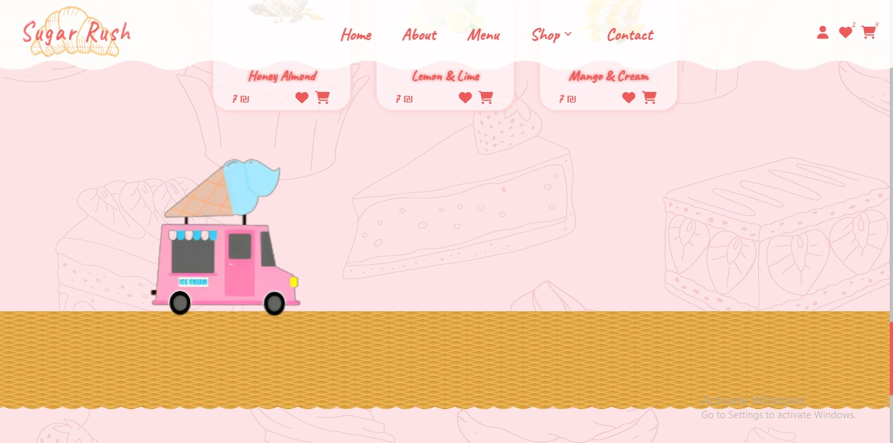

# **Single product veiw**

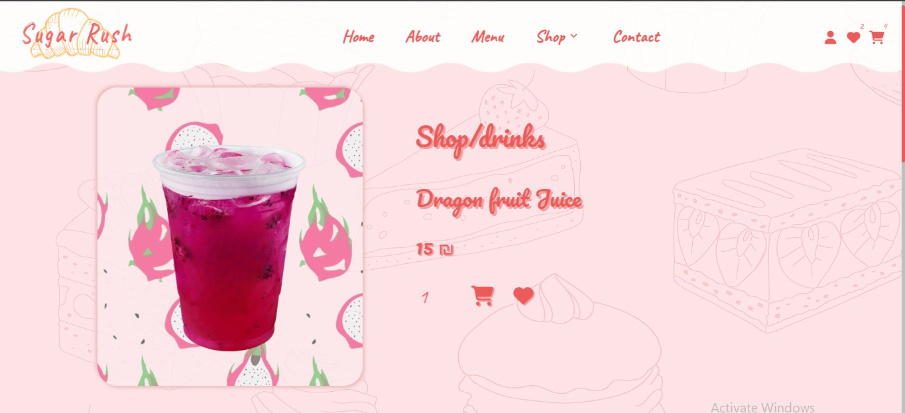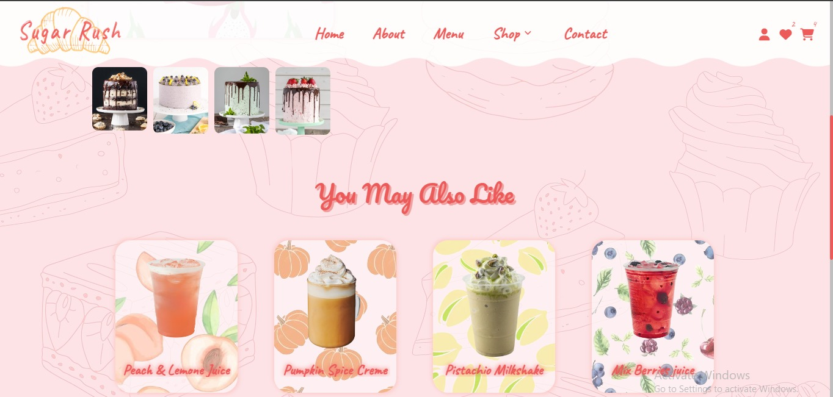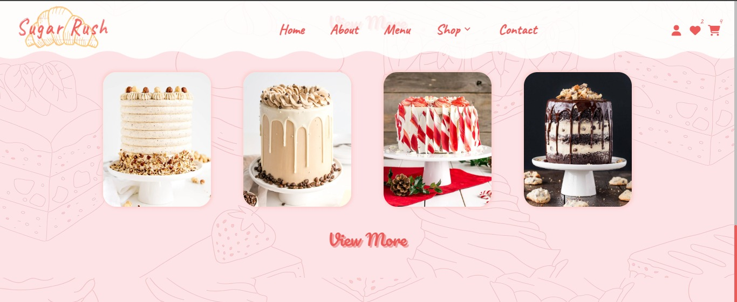

# **Sign in**

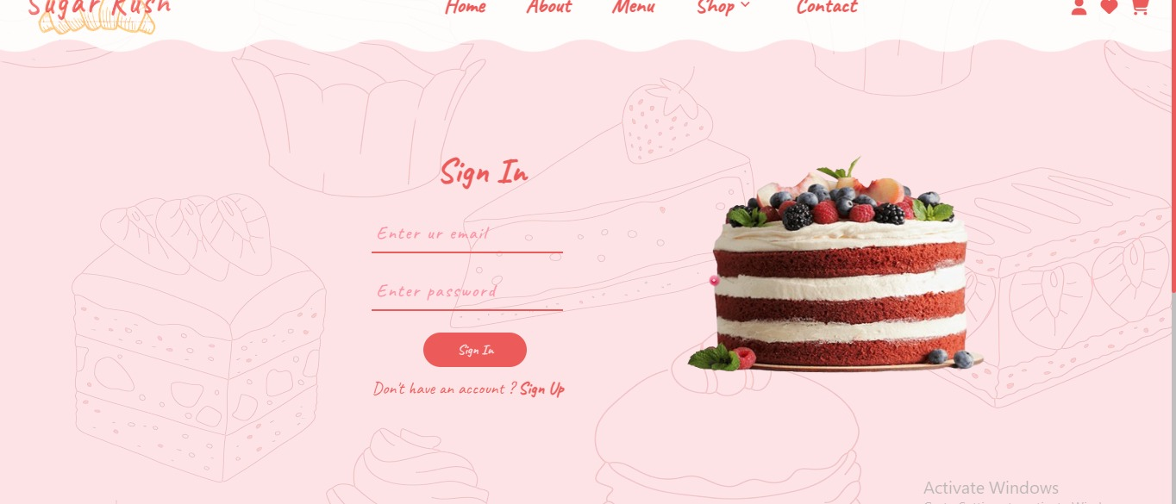

# **Sign up**

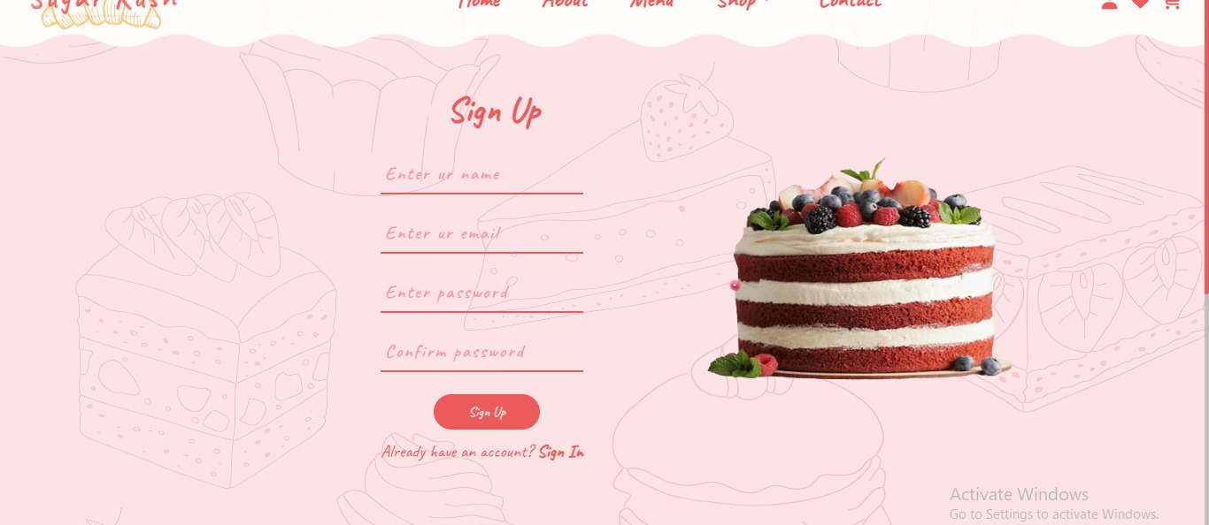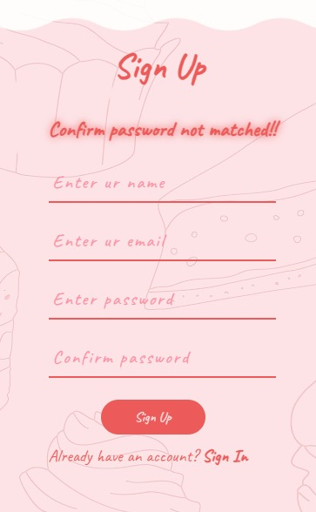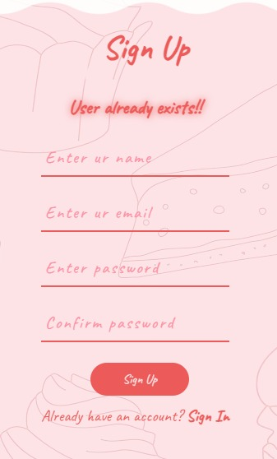

# **User profile**

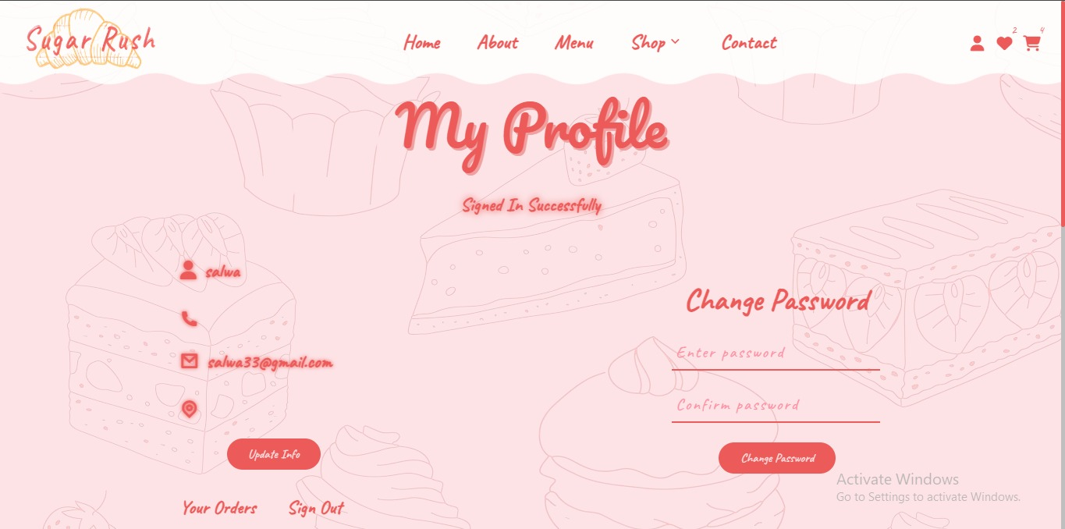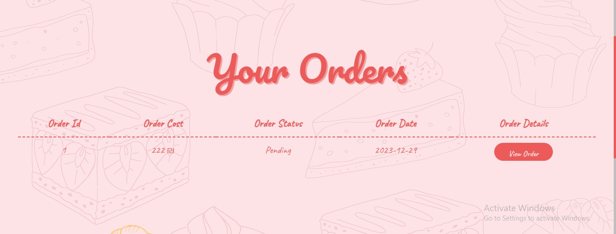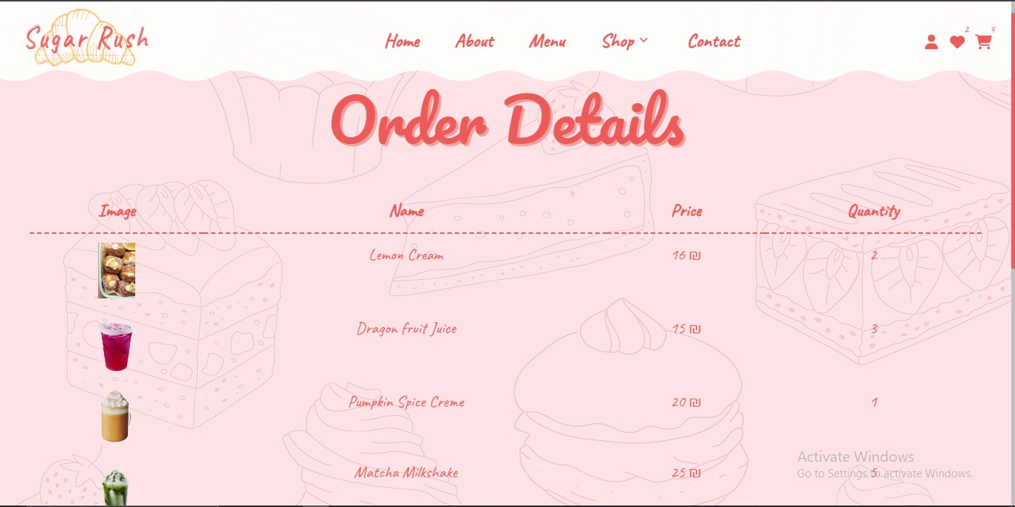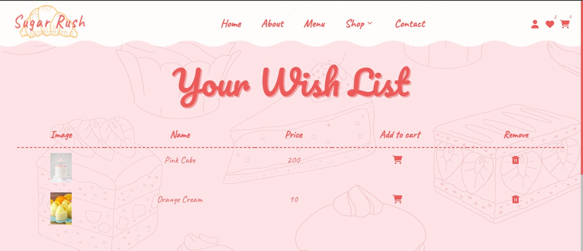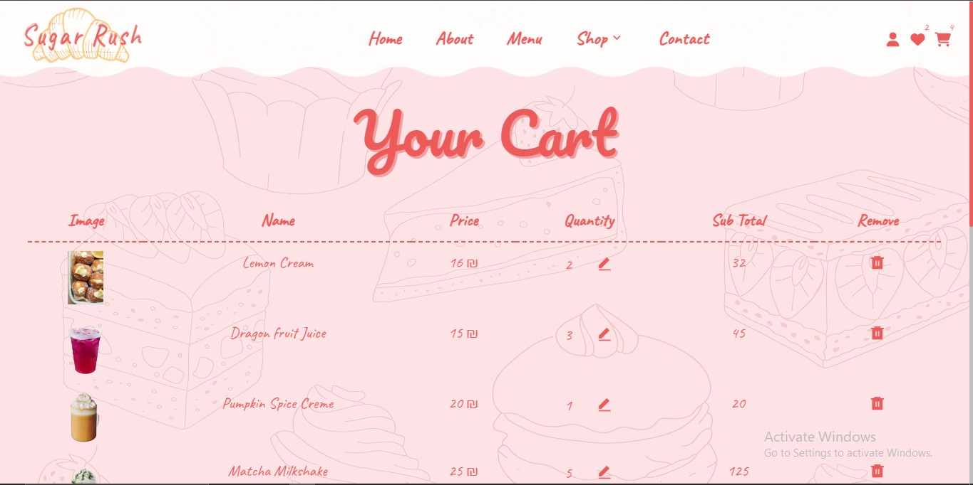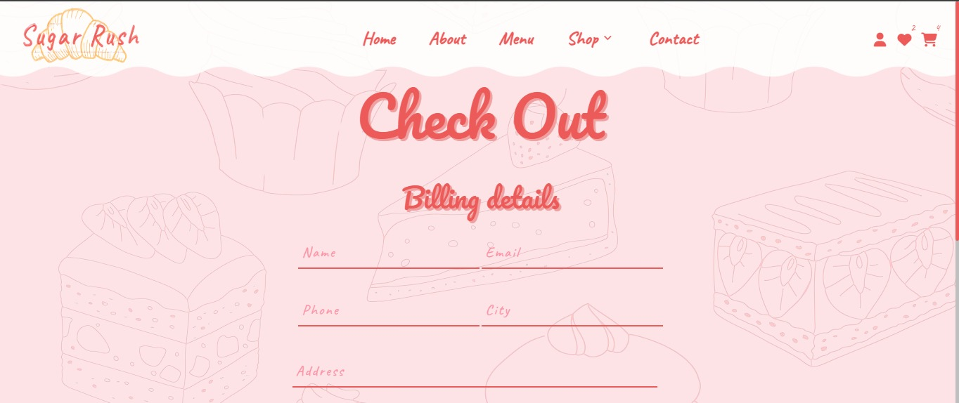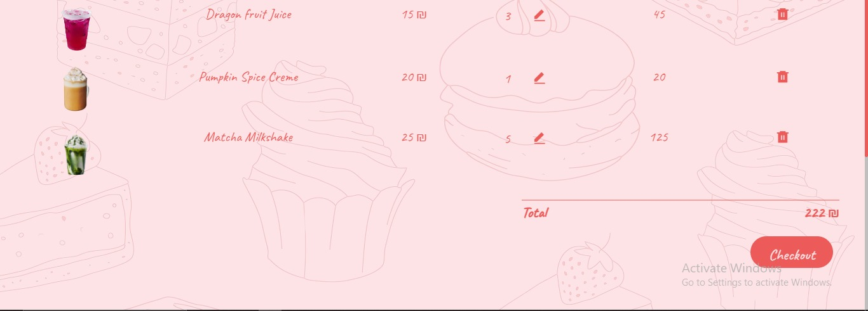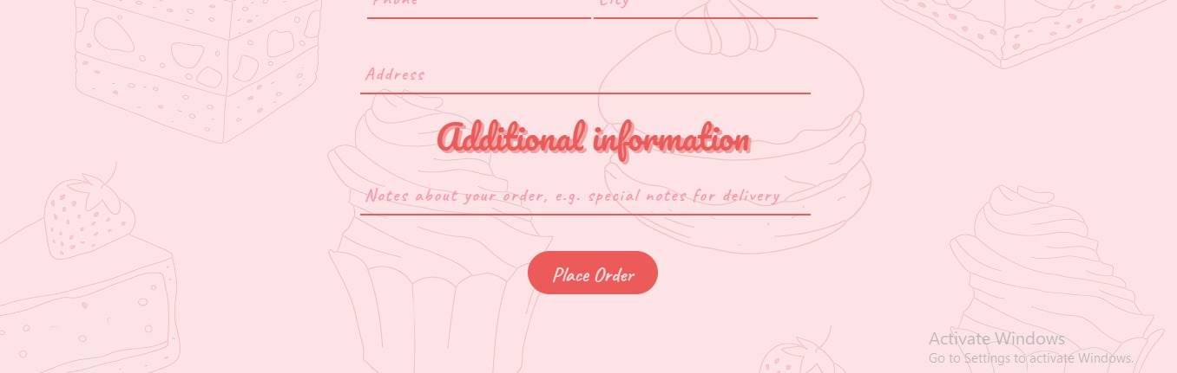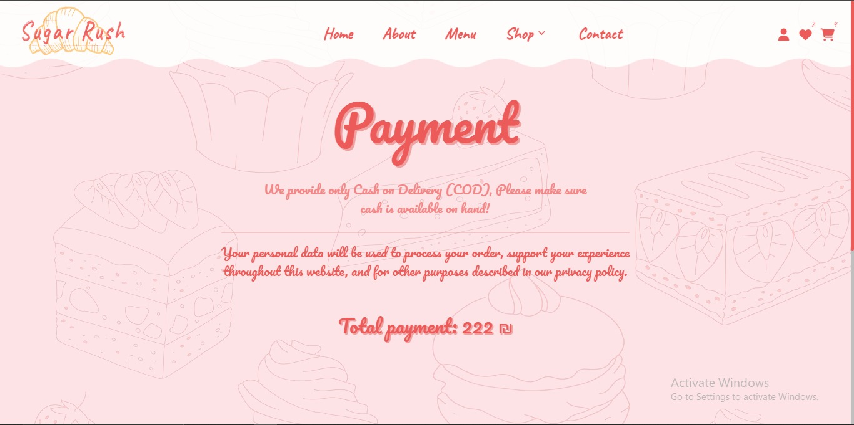

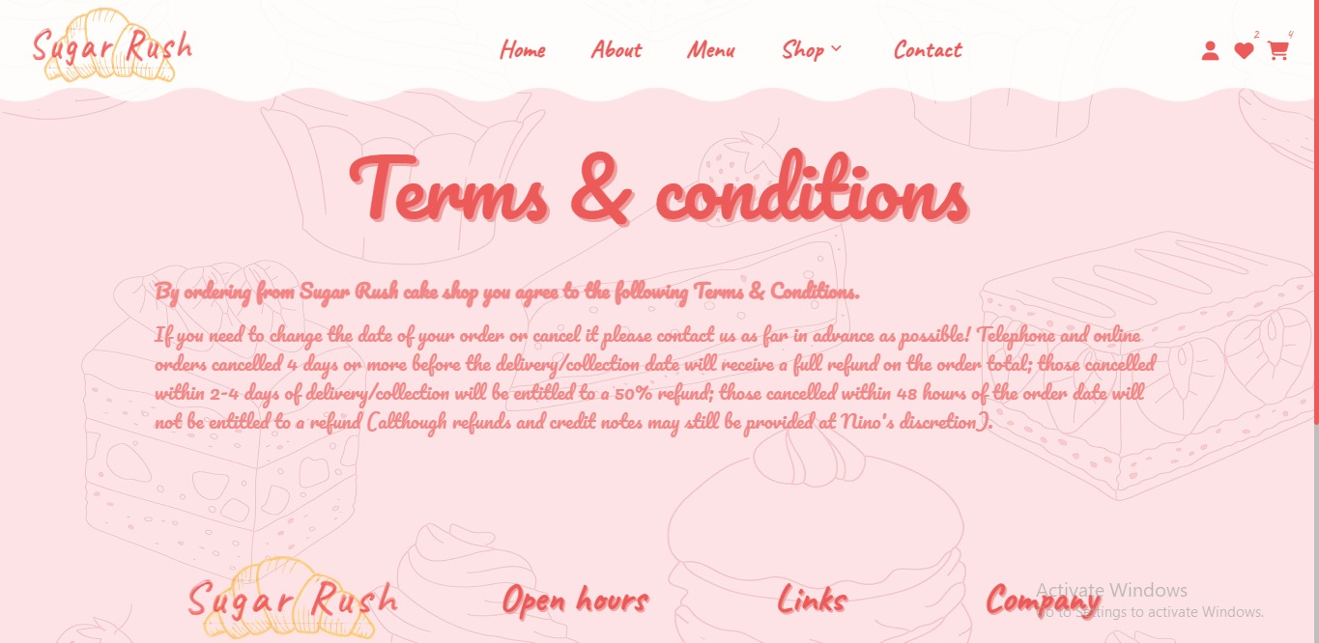

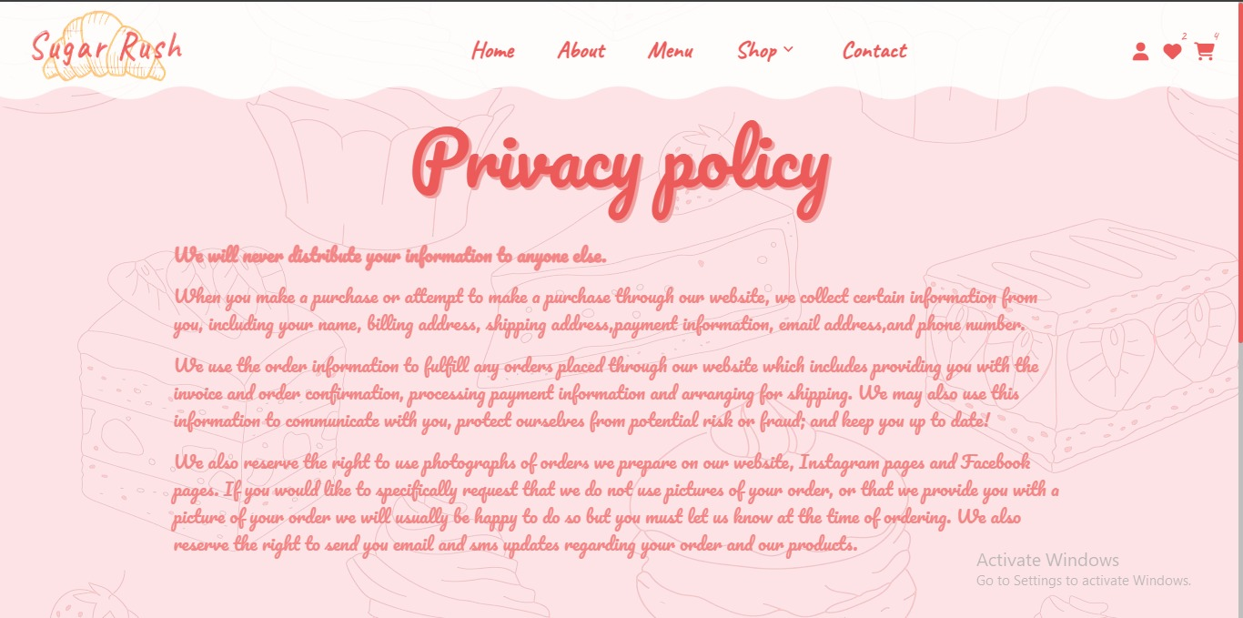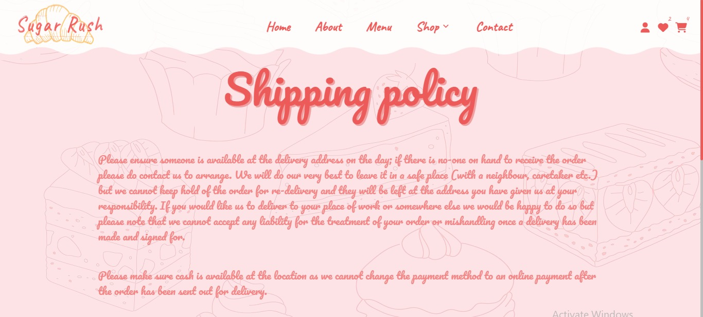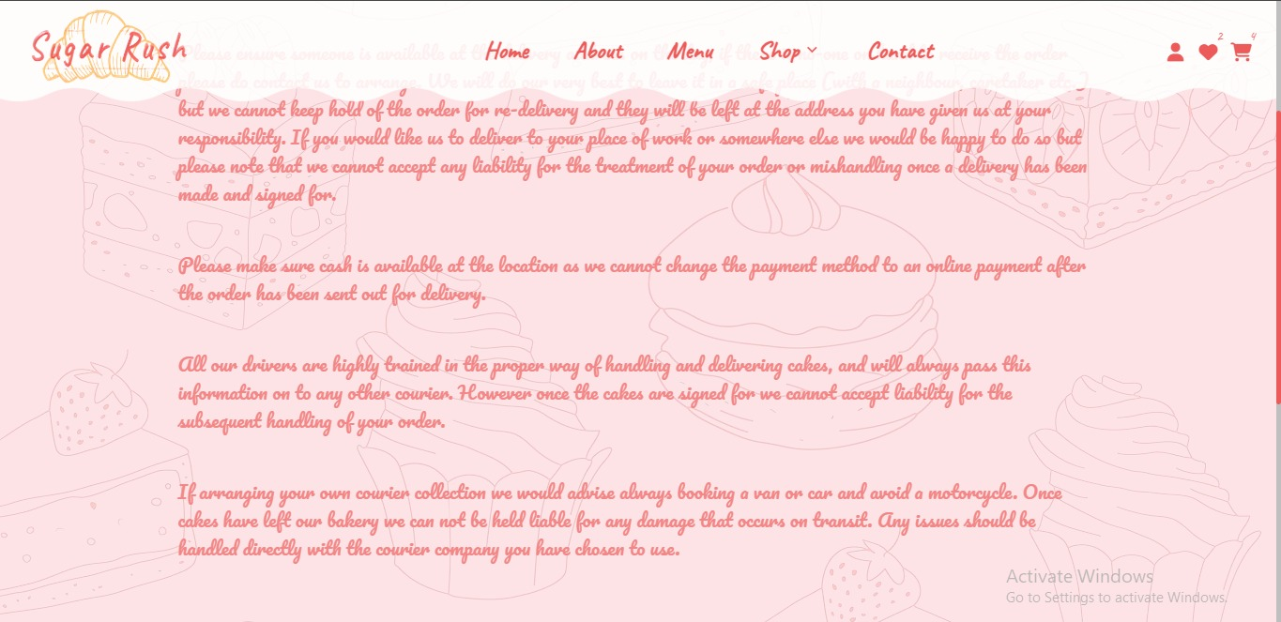

# **Admin**

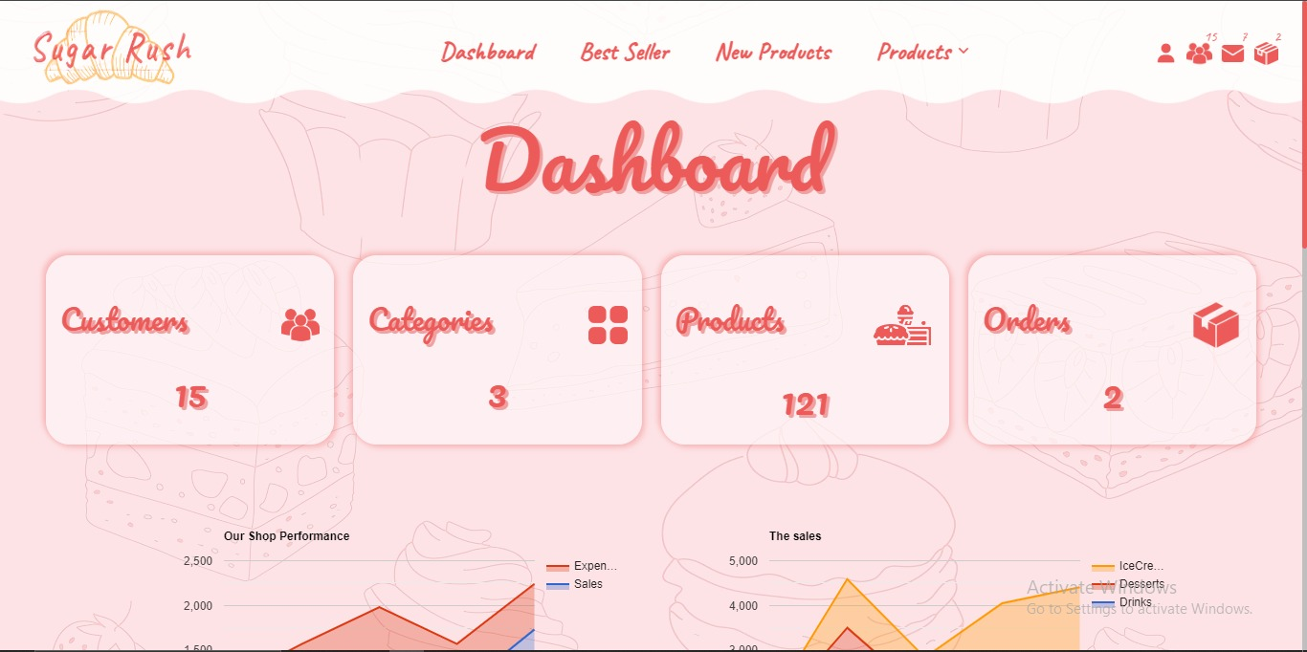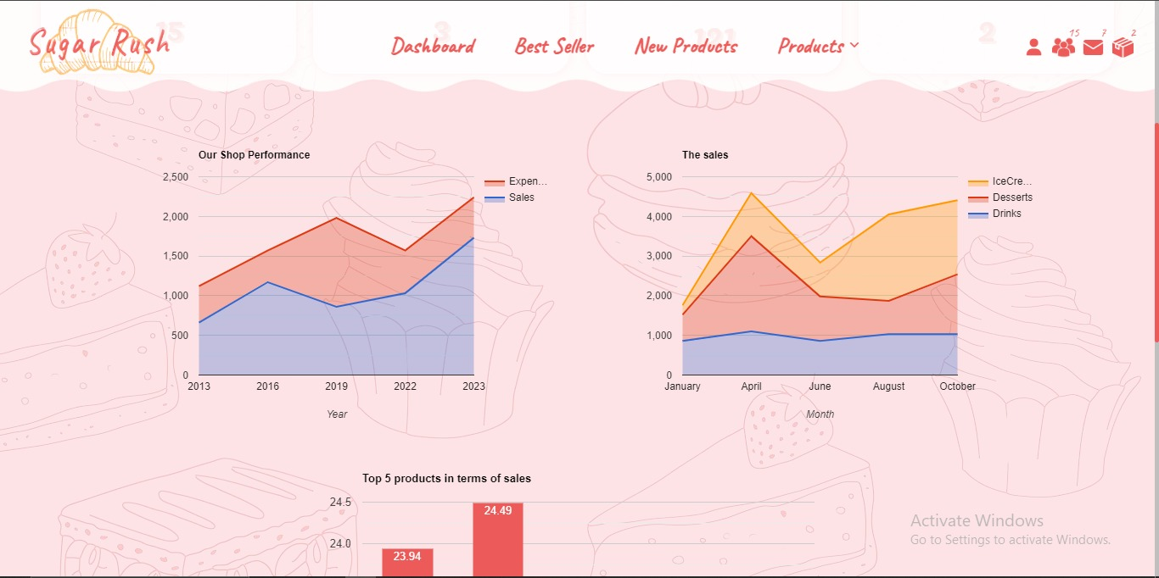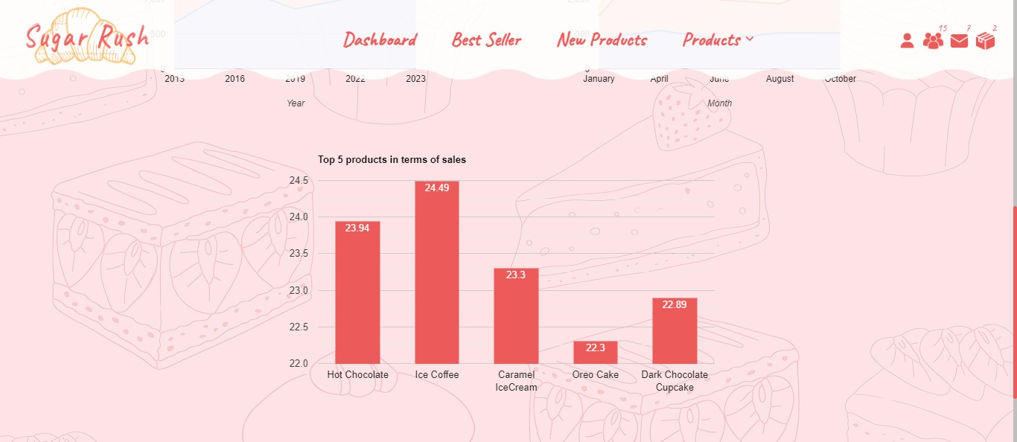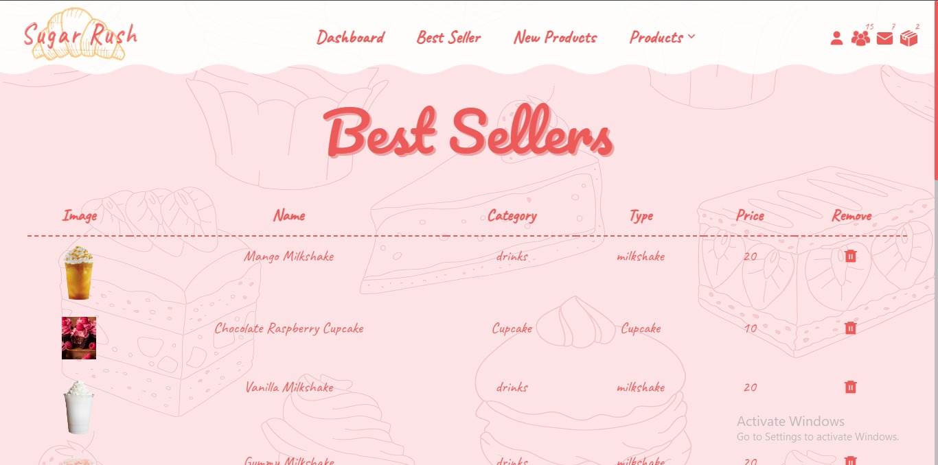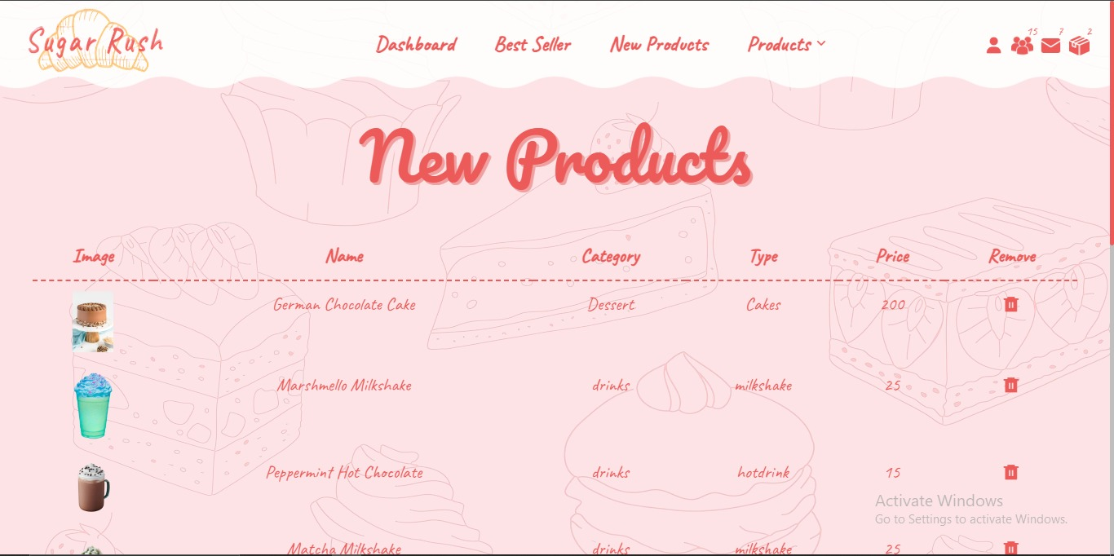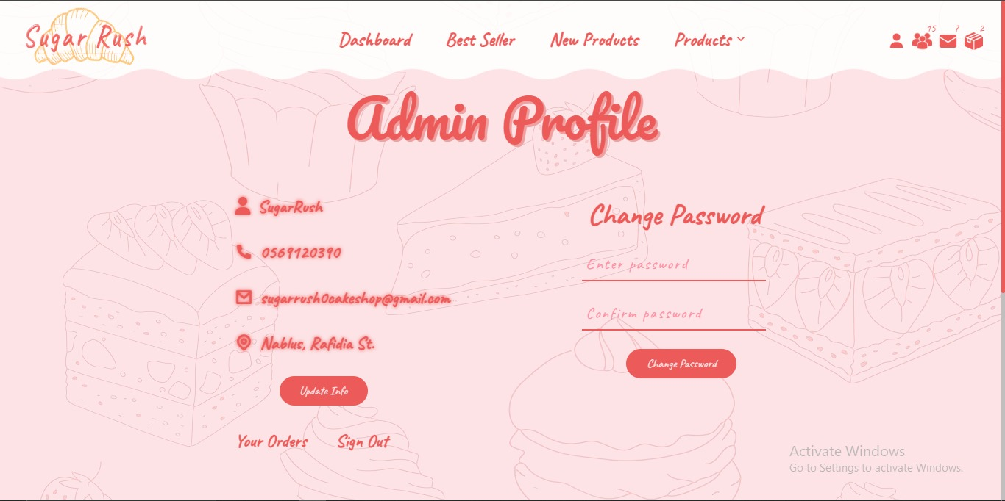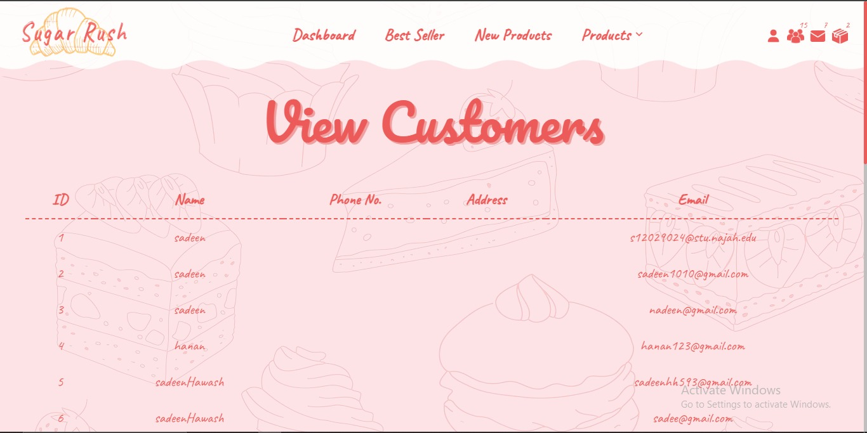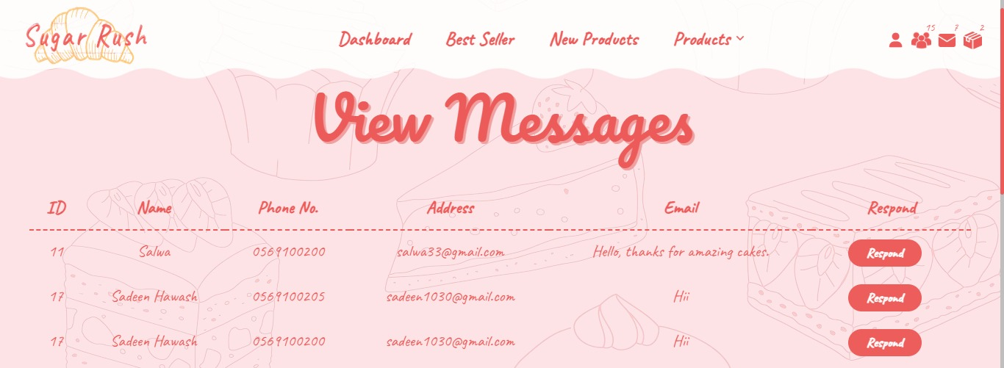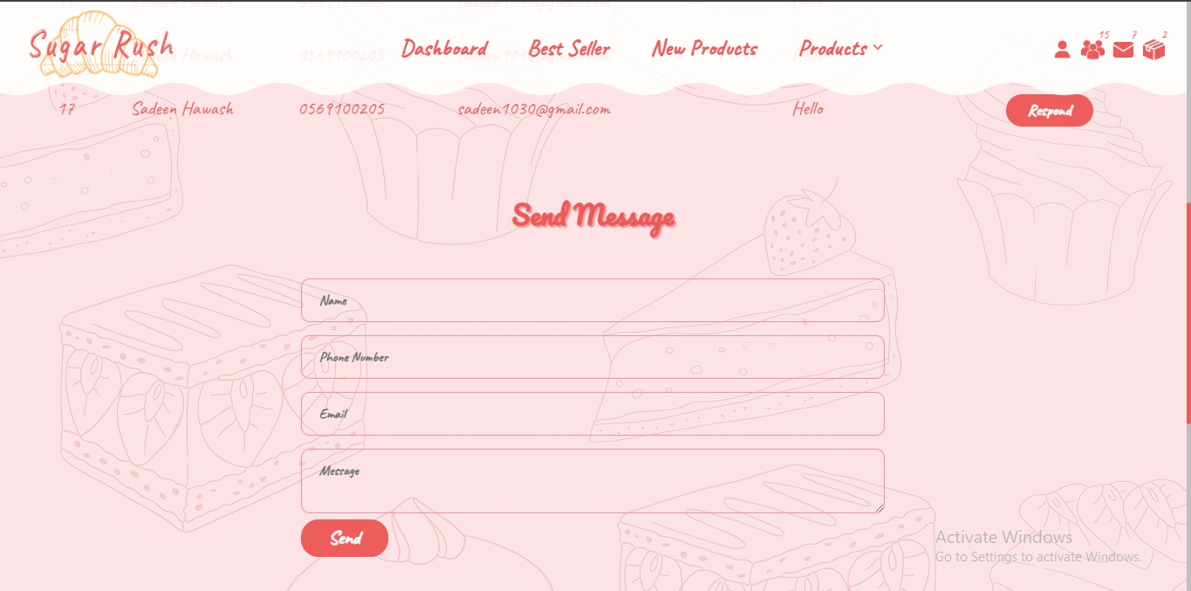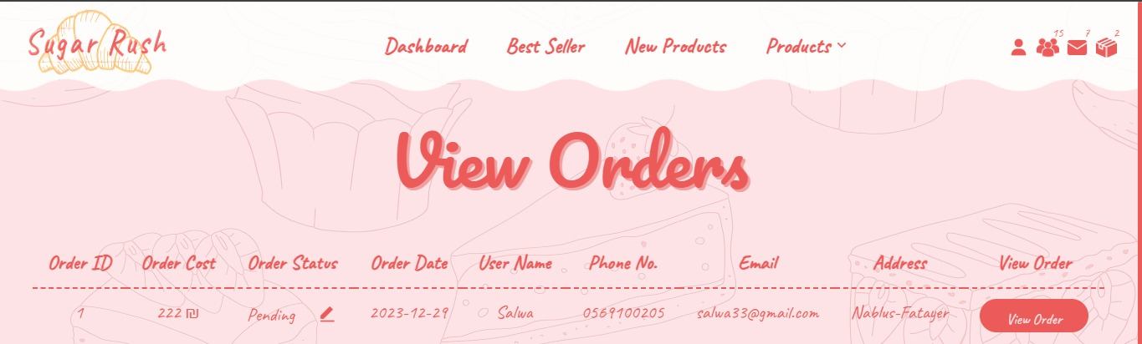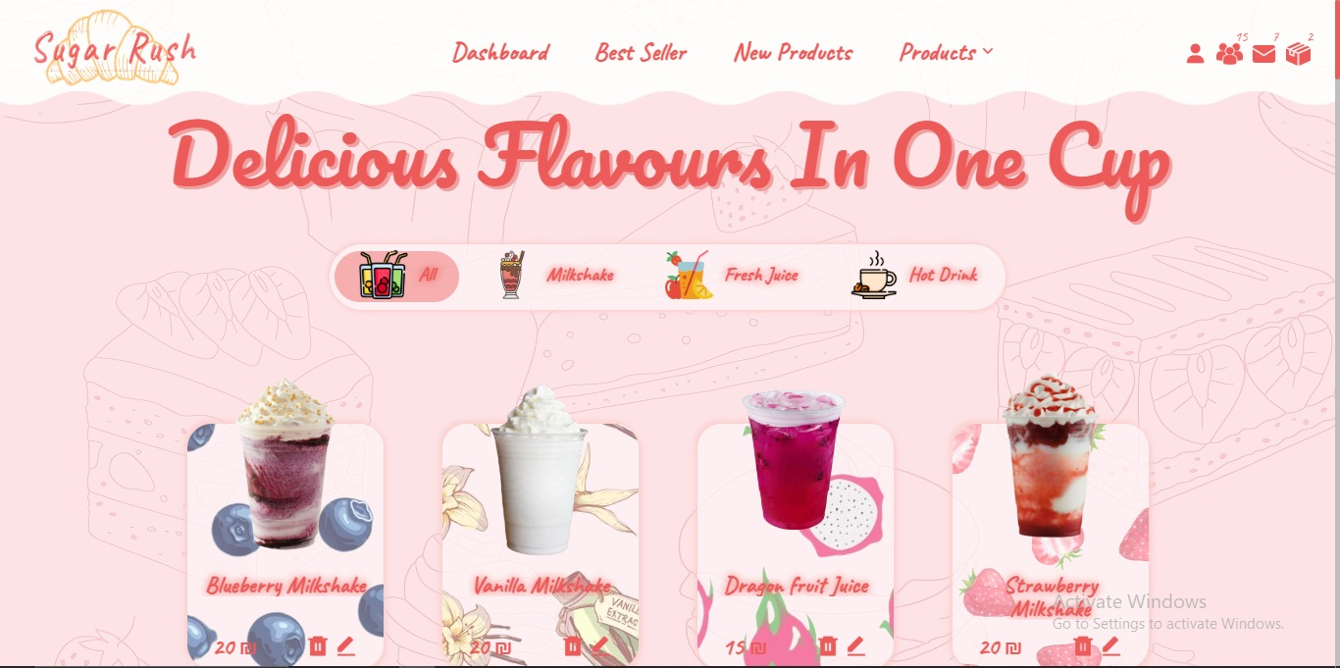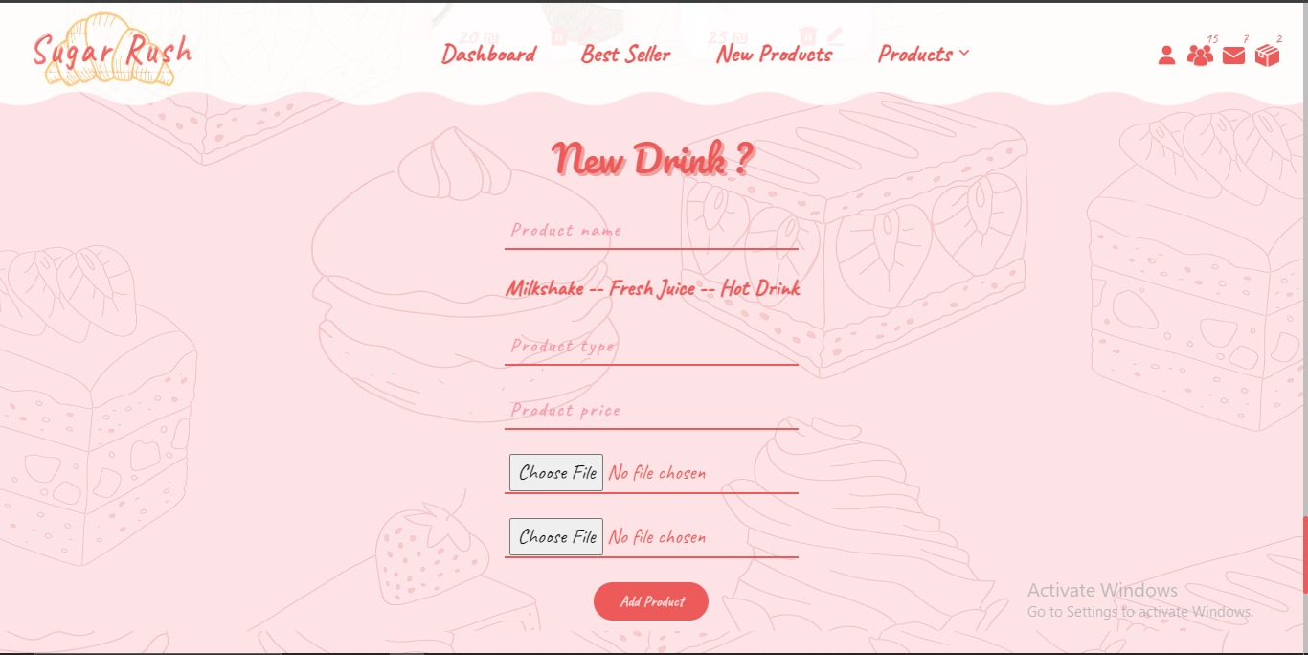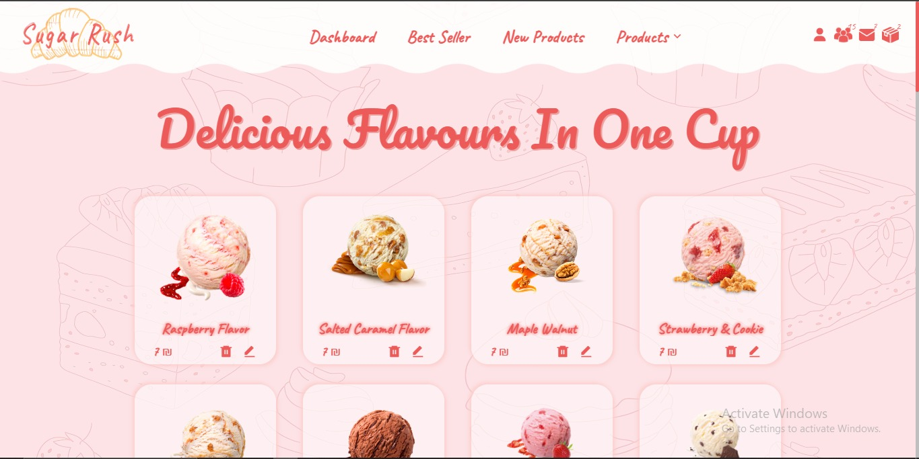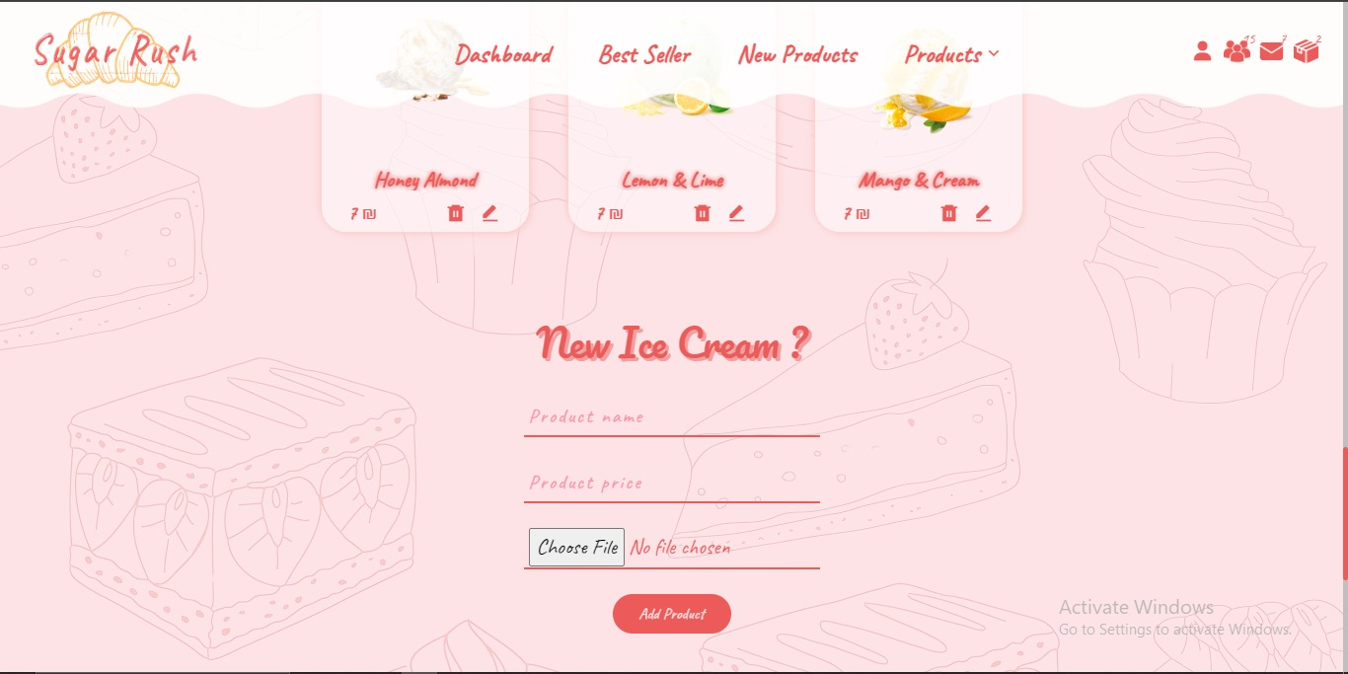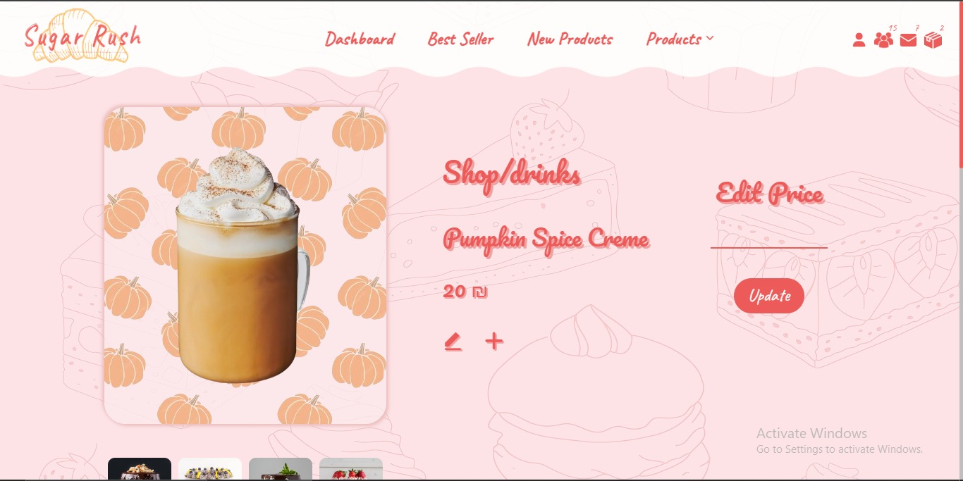

# **Responsive**

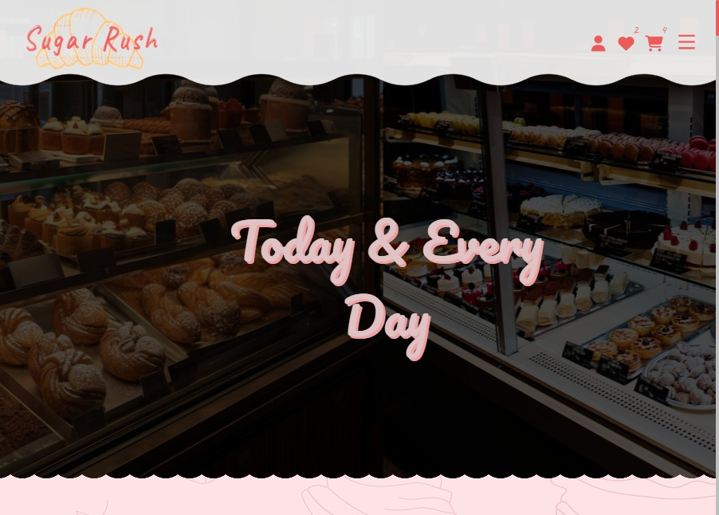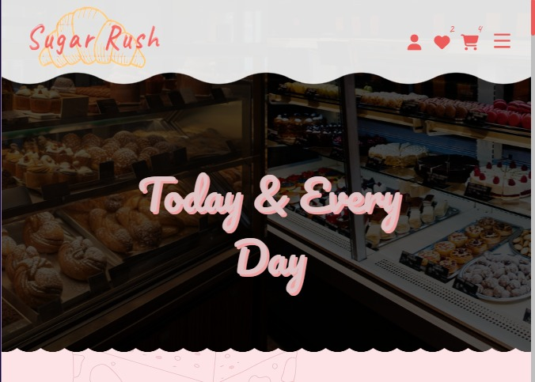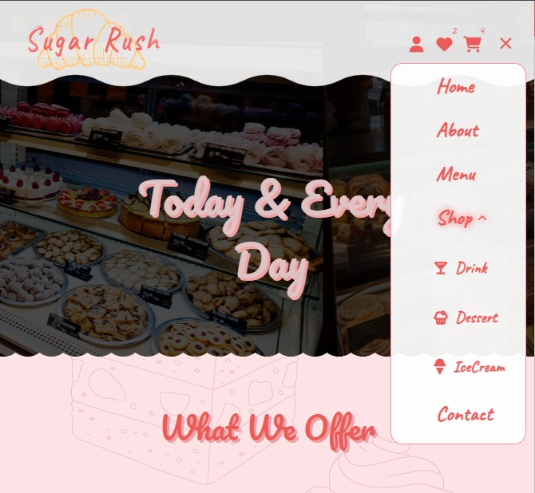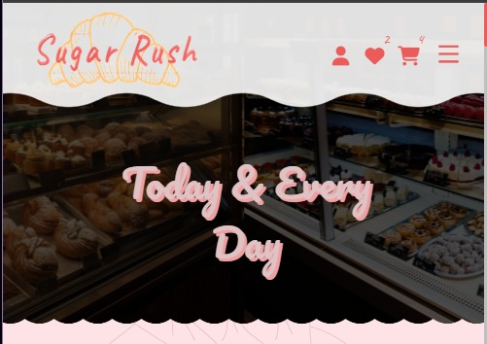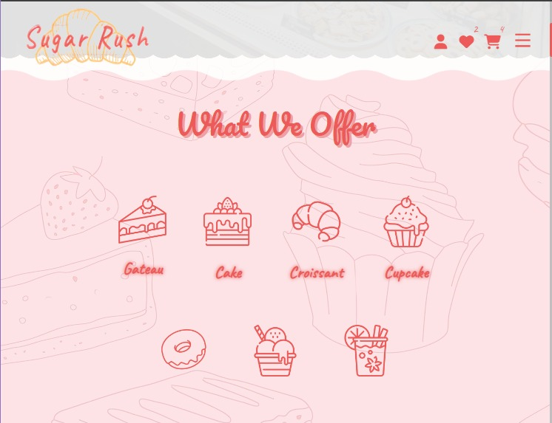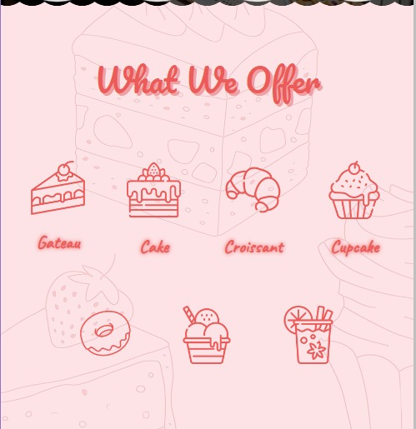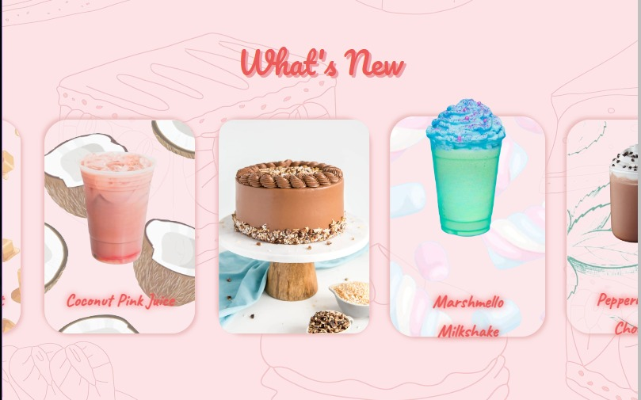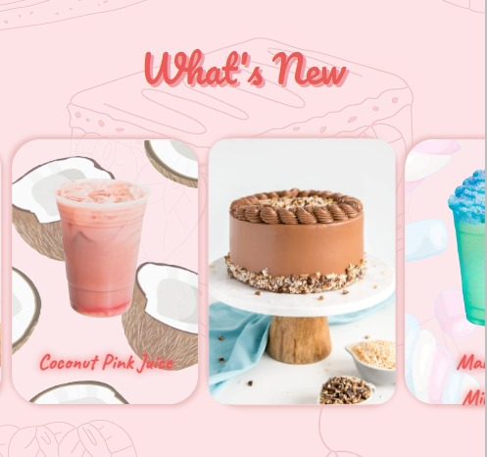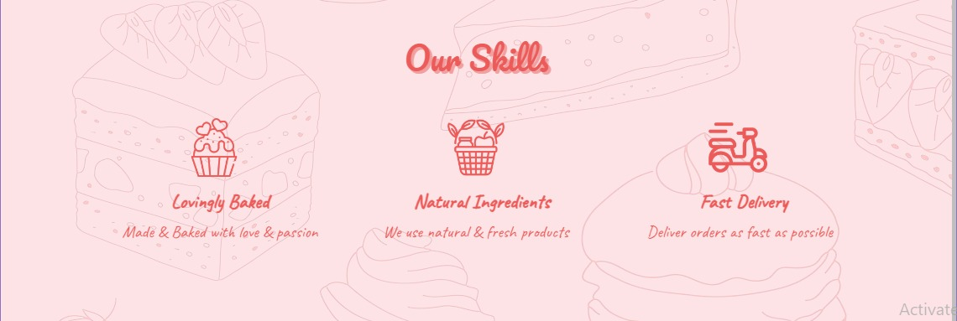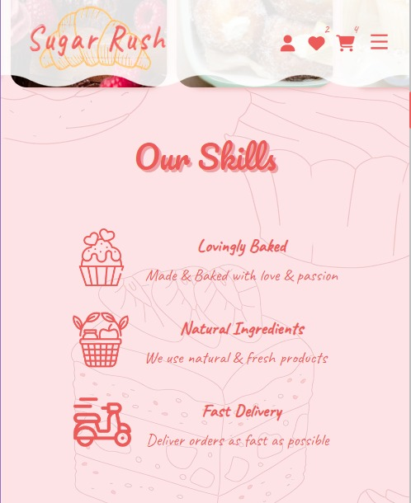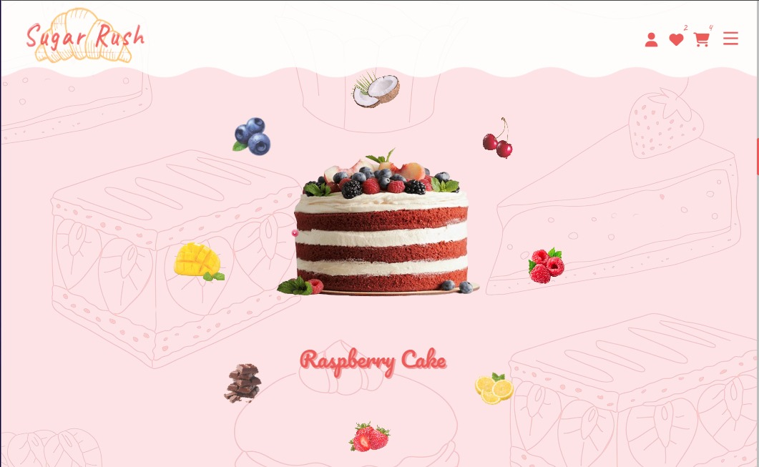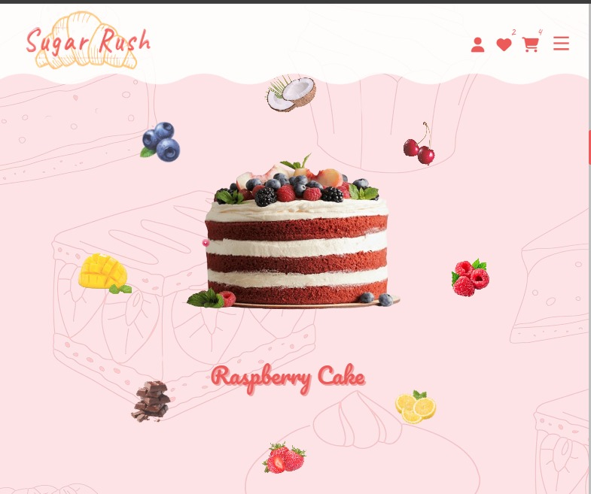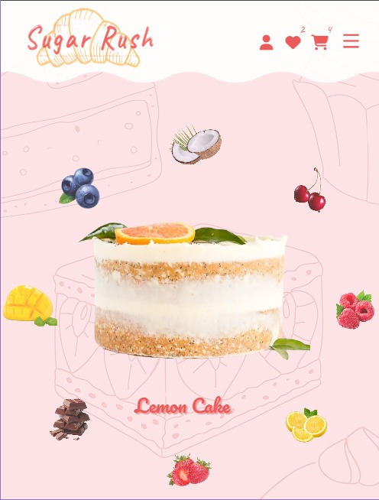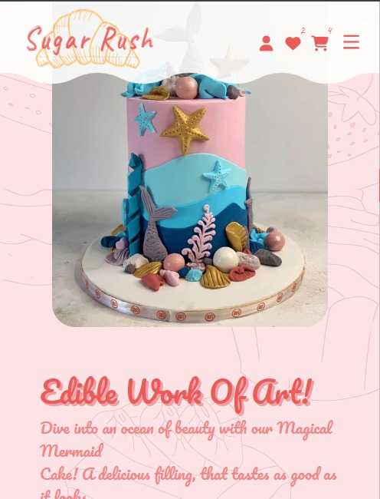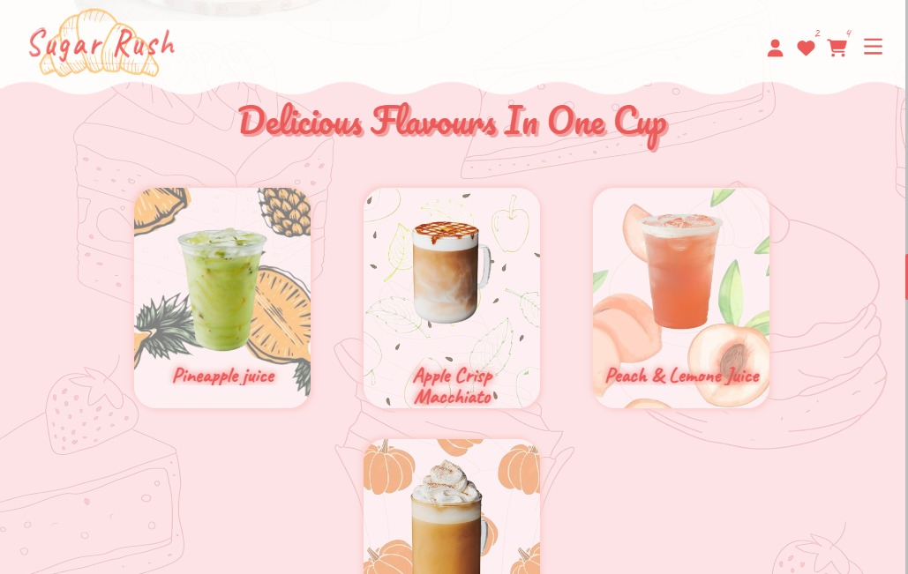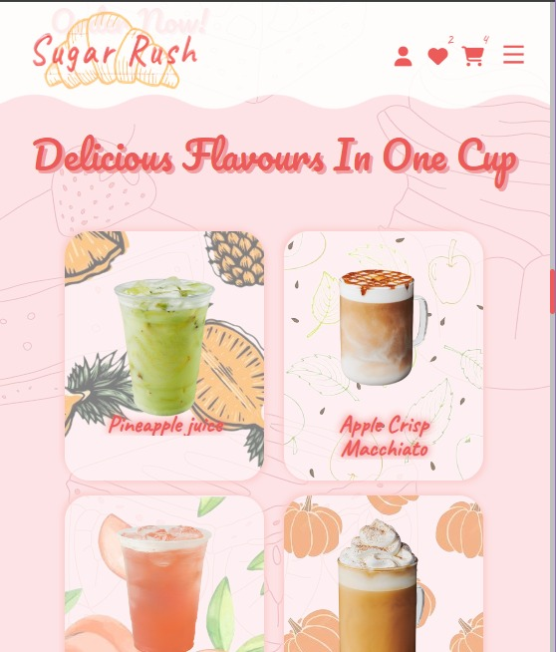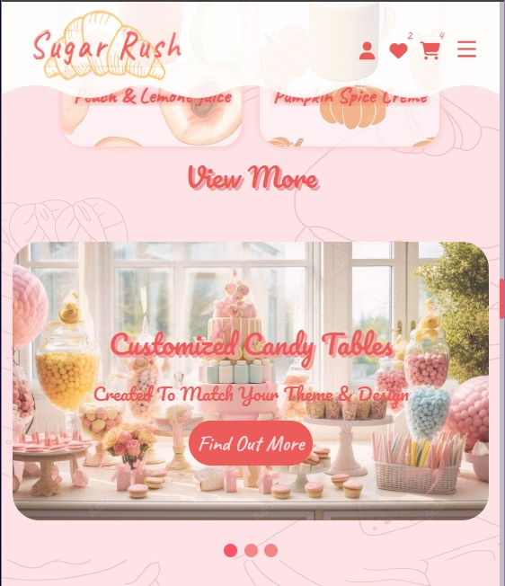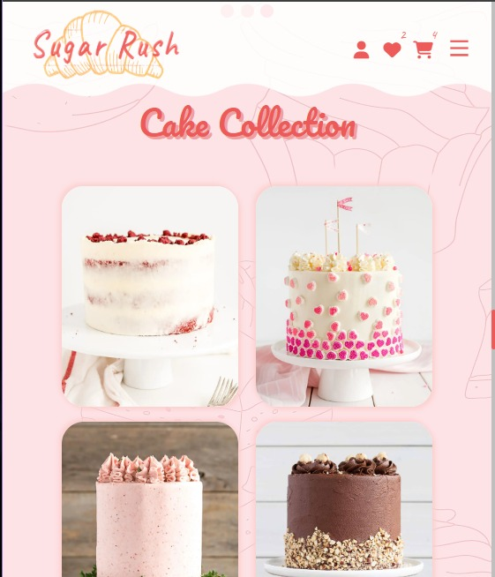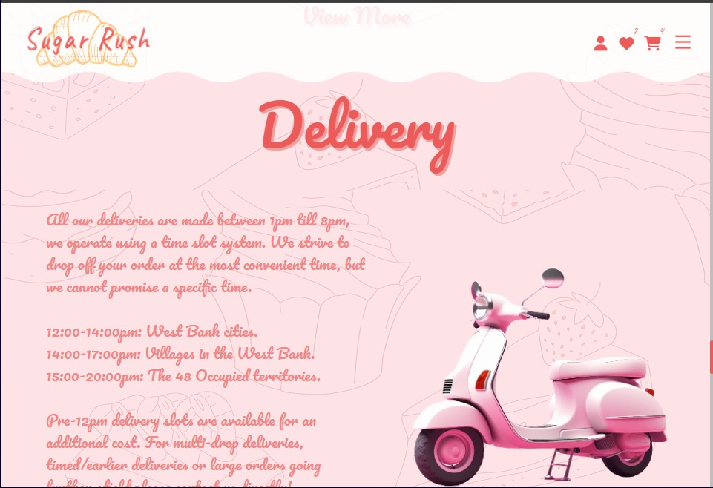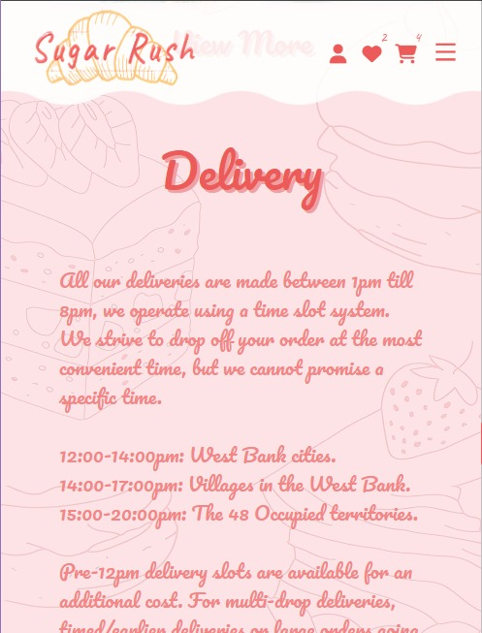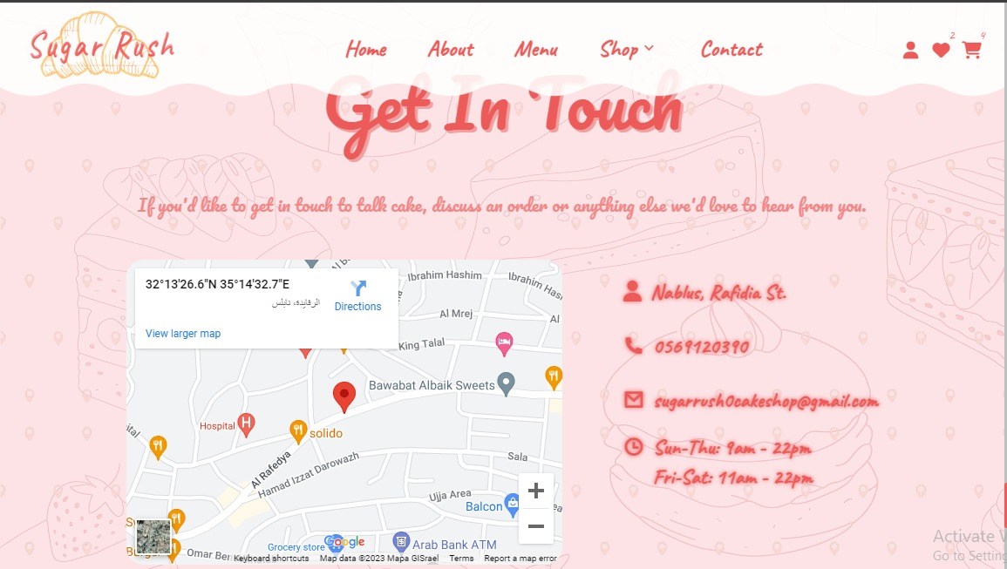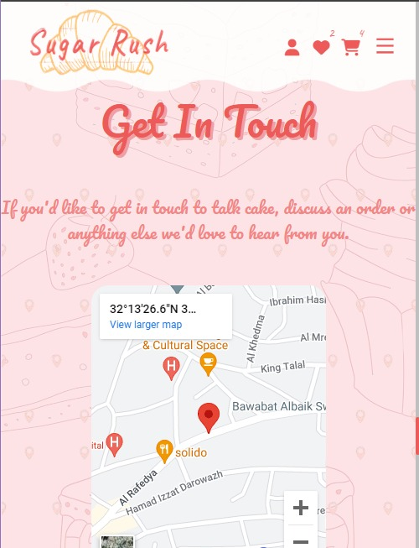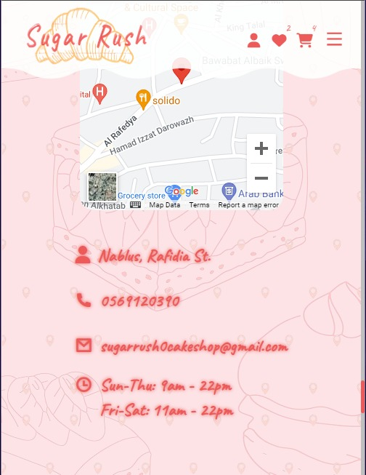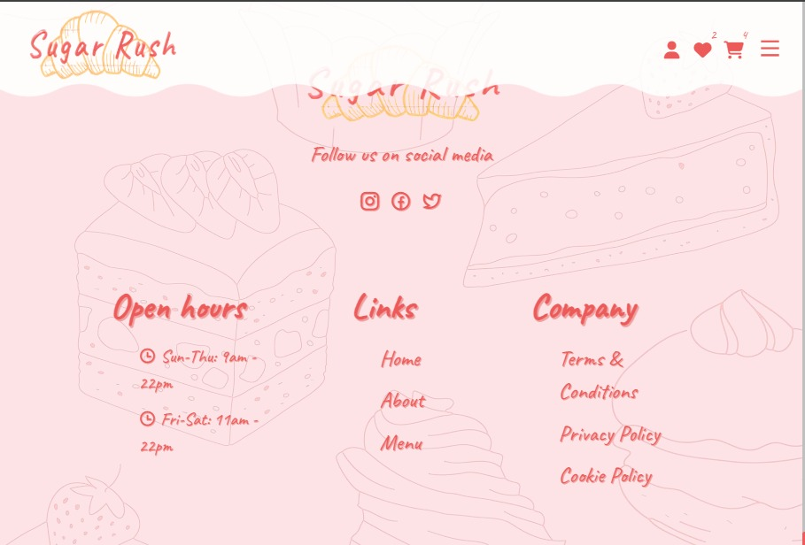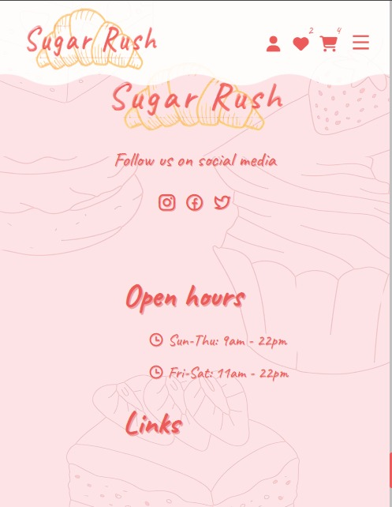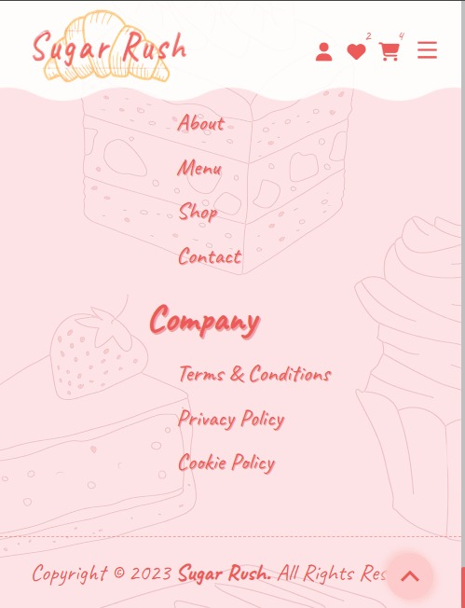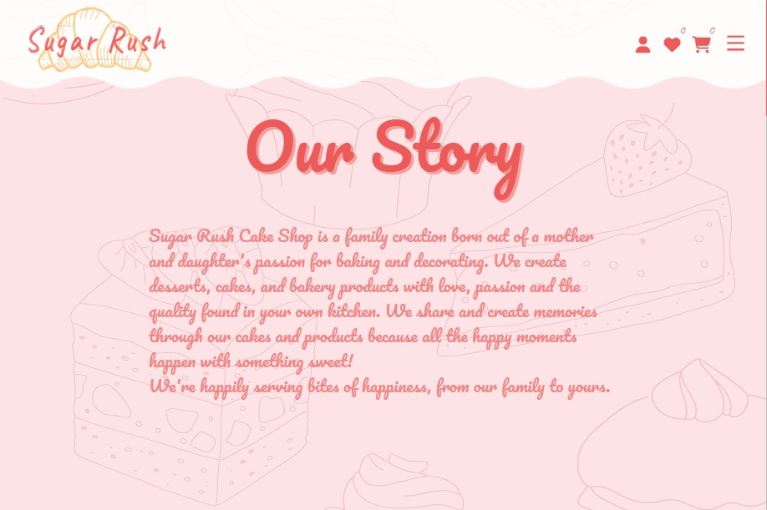

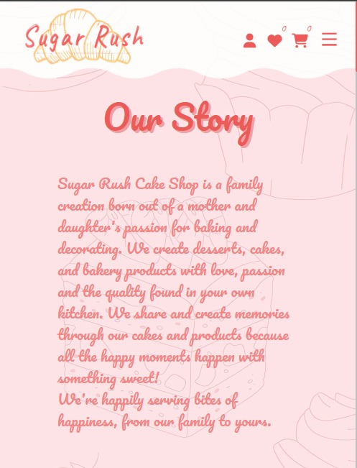

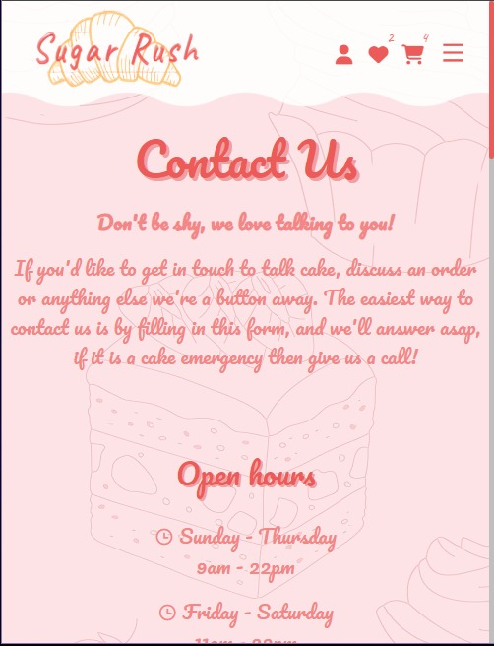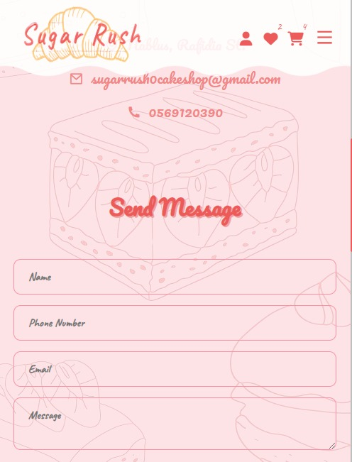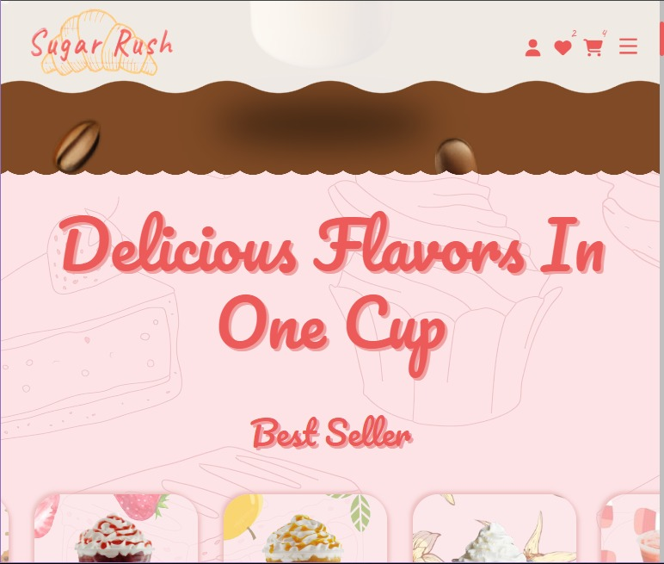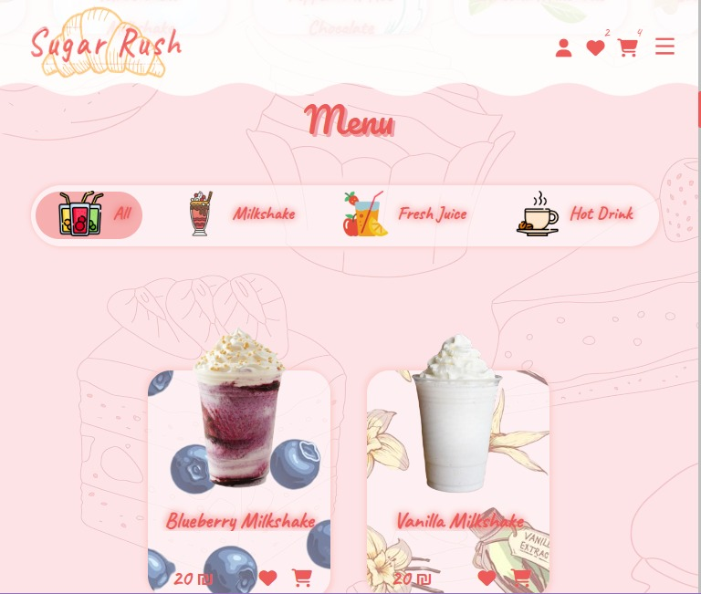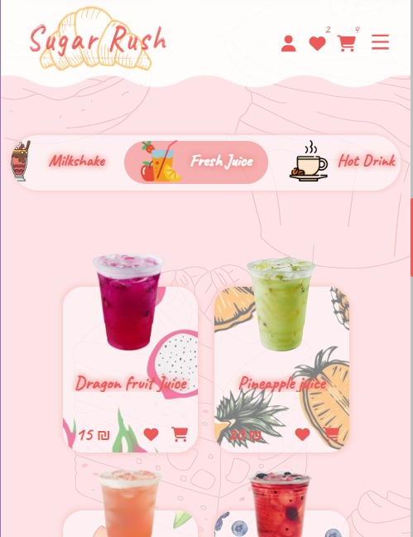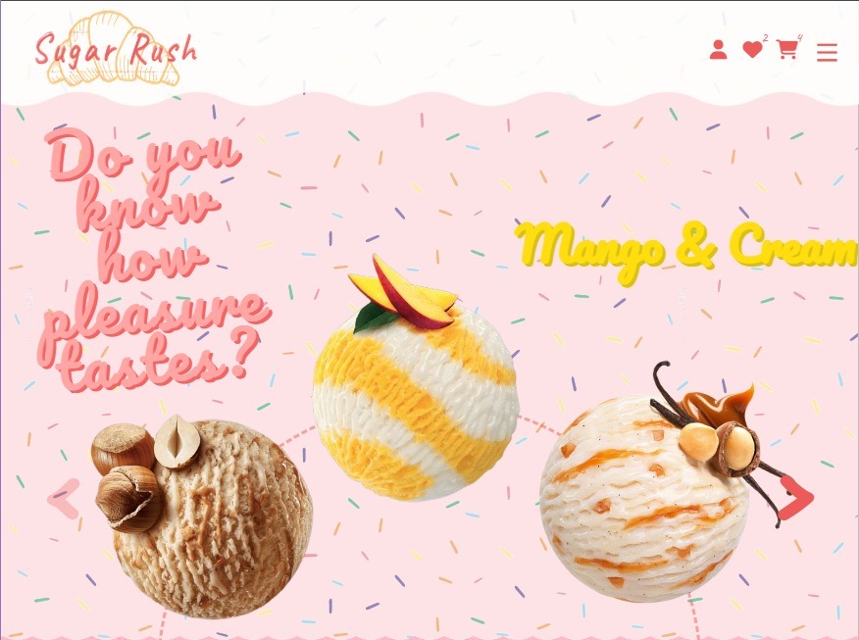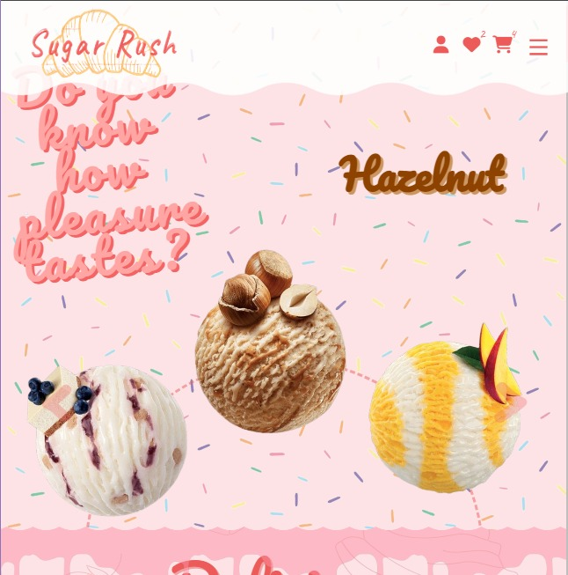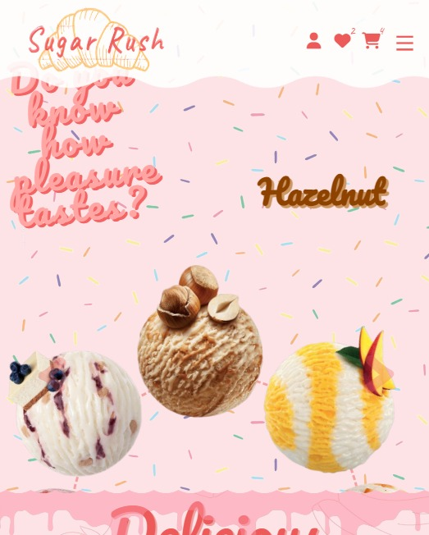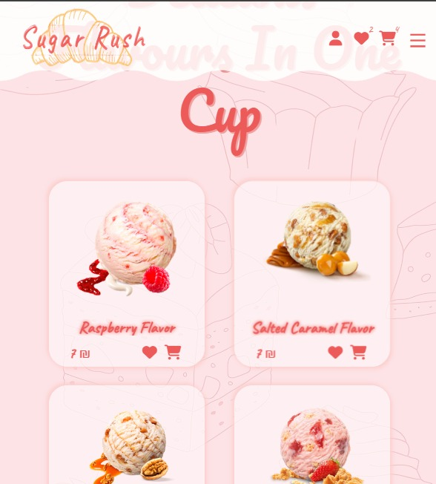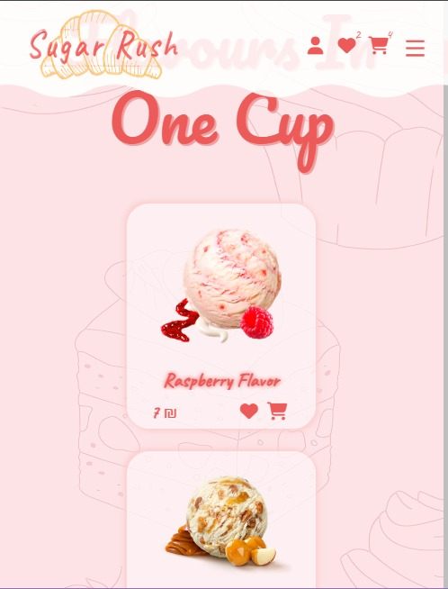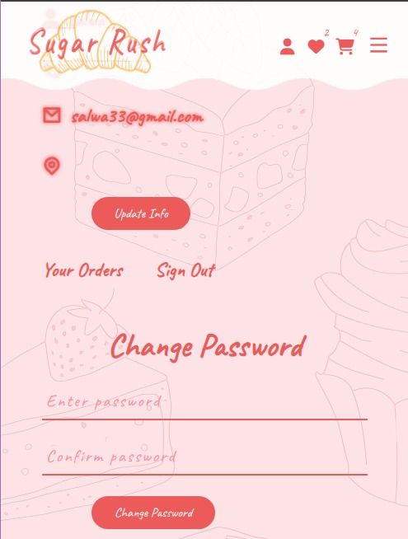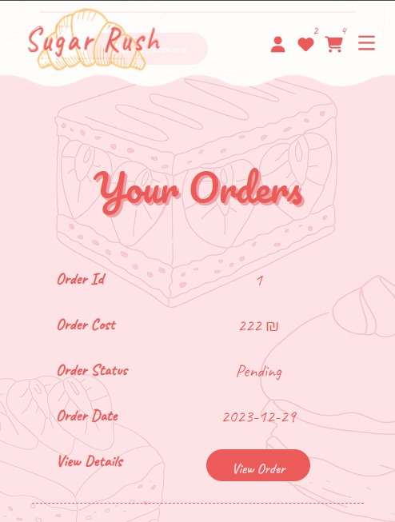

# **Tables**

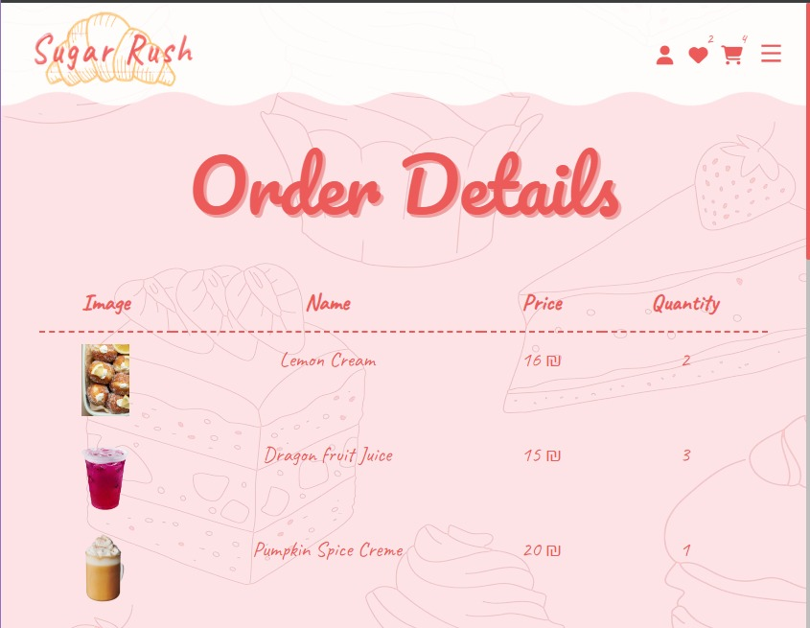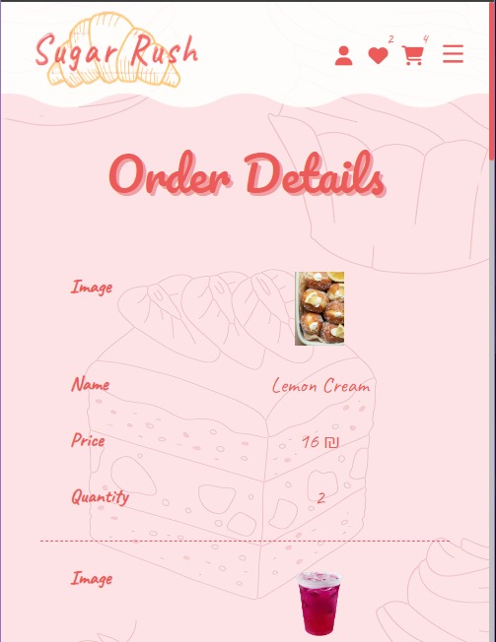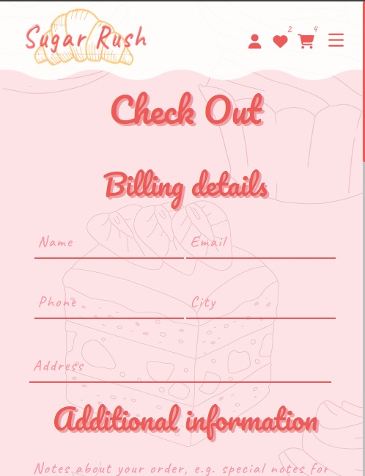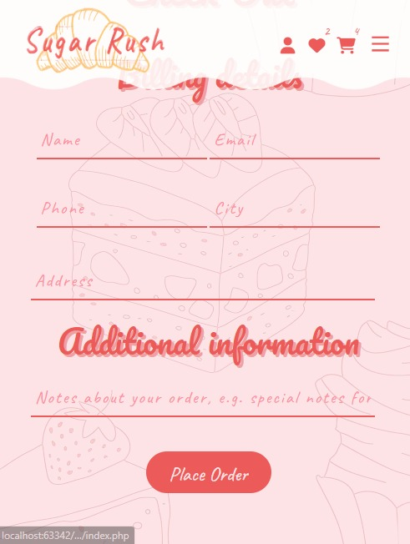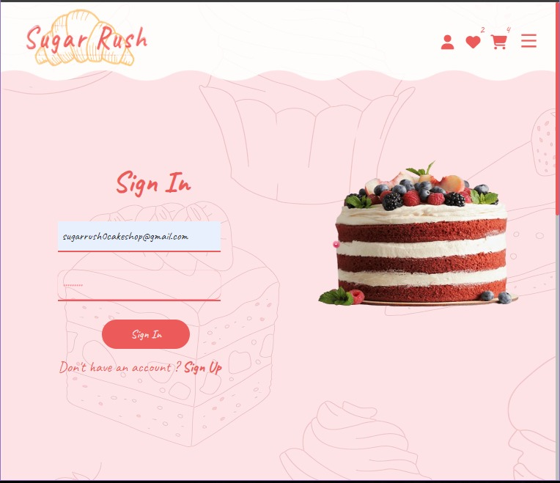

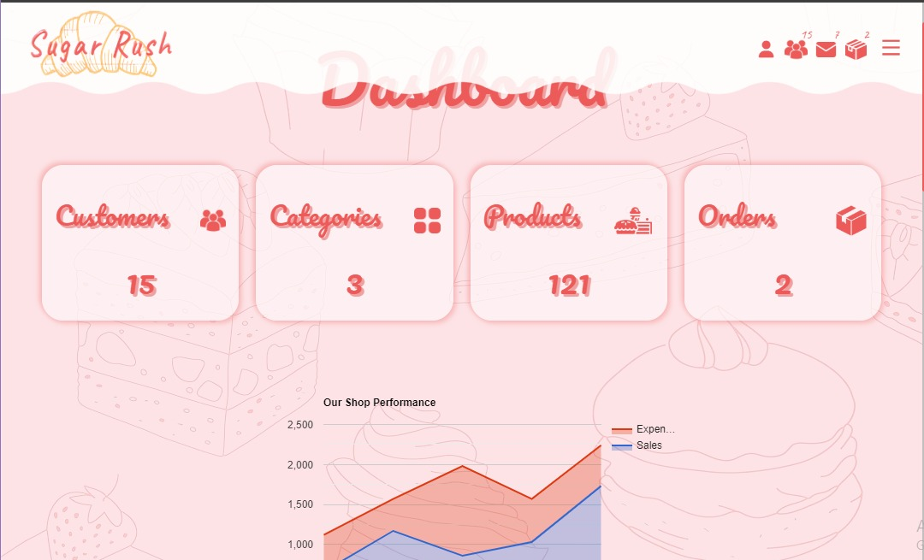



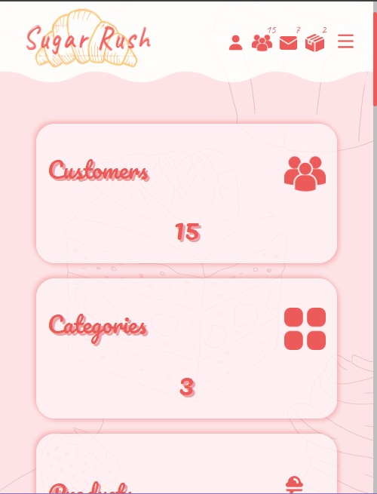

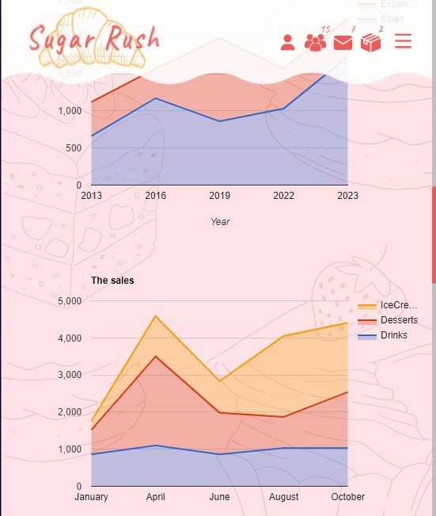

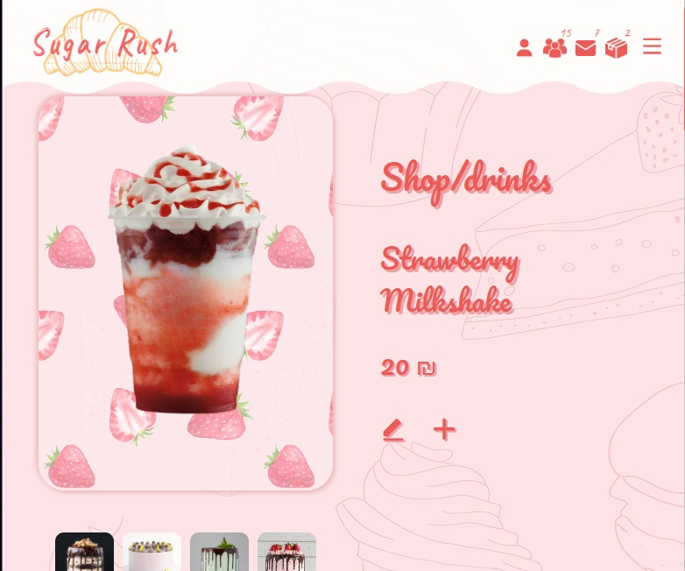

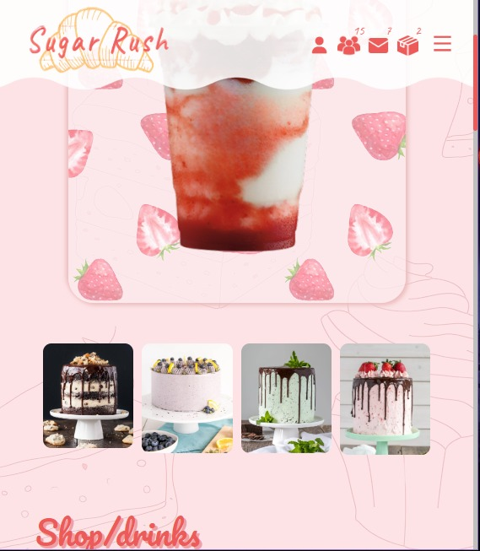

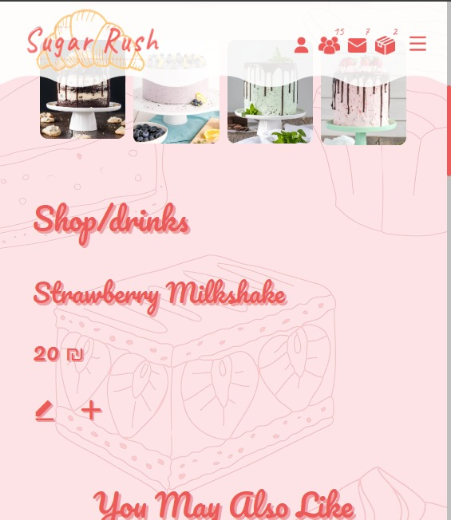

# **Conclusion**

In summary, our project aspires to be a holistic sanctuary, meeting the cravings for delightful treats and providing all the essentials for creating a personal dessert haven. Beyond that, it extends to those who appreciate the natural beauty of gifts, turning every visit into a celebration of life's sweet joys. Join us in this digital confectionery, where every interaction is an opportunity to craft and savor sweet moments.

\

# **Refrences**

[**https://getbootstrap.com**](https://getbootstrap.com)

[**https://www.w3schools.com**](https://www.w3schools.com)

[**https://swiperjs.com/**](https://swiperjs.com/)

[**https://gsap.com/community/forums/topic/26454-using-scrollto-plugin-with-a-smooth-scrolling-page/**](https://gsap.com/community/forums/topic/26454-using-scrollto-plugin-with-a-smooth-scrolling-page/)

**YouTube**

**Sildes**

**font:** [**https://fonts.googleapis.com/css?family=Caveat**](https://fonts.googleapis.com/css?family=Caveat)

**icons:** [**https://cdn.jsdelivr.net/npm/remixicon@3.2.0/fonts/remixicon.css**](https://cdn.jsdelivr.net/npm/remixicon@3.2.0/fonts/remixicon.css)

[**https://cdnjs.cloudflare.com/ajax/libs/font-awesome/6.4.2/css/all.min.css**](https://cdnjs.cloudflare.com/ajax/libs/font-awesome/6.4.2/css/all.min.css)

**js:**

[**https://cdnjs.cloudflare.com/ajax/libs/gsap/3.12.4/gsap.min.js**](https://cdnjs.cloudflare.com/ajax/libs/gsap/3.12.4/gsap.min.js)

[**https://gsap.com/scroll/**](https://gsap.com/scroll/)

[**https://cdnjs.cloudflare.com/ajax/libs/fancybox/3.5.7/jquery.fancybox.min.js**](https://cdnjs.cloudflare.com/ajax/libs/fancybox/3.5.7/jquery.fancybox.min.js)

[**https://popper.js.org/**](https://popper.js.org/)

[**https://cdnjs.cloudflare.com/ajax/libs/font-awesome/6.5.1/js/all.min.js**](https://cdnjs.cloudflare.com/ajax/libs/font-awesome/6.5.1/js/all.min.js)

[**https://cdnjs.cloudflare.com/ajax/libs/bootstrap/5.3.2/js/bootstrap.min.js**](https://cdnjs.cloudflare.com/ajax/libs/bootstrap/5.3.2/js/bootstrap.min.js)

[**https://cdnjs.cloudflare.com/ajax/libs/jquery/3.7.1/jquery.min.js**](https://cdnjs.cloudflare.com/ajax/libs/jquery/3.7.1/jquery.min.js)

[**https://cdnjs.cloudflare.com/ajax/libs/mixitup/3.3.1/mixitup.min.js**](https://cdnjs.cloudflare.com/ajax/libs/mixitup/3.3.1/mixitup.min.js)